**WEEK-5 ACTIVITY 2**

**INSTALLATION OF JDK, MAVEN, TOMCAT AND CONFIGURING TOMCAT INTO ECLIPSE**

**BY S.ASHA**

**22BD1A059J**

* **INSTALLATION OF JDK:**

1. **Search for jdk download on google and visit the official oracle website**

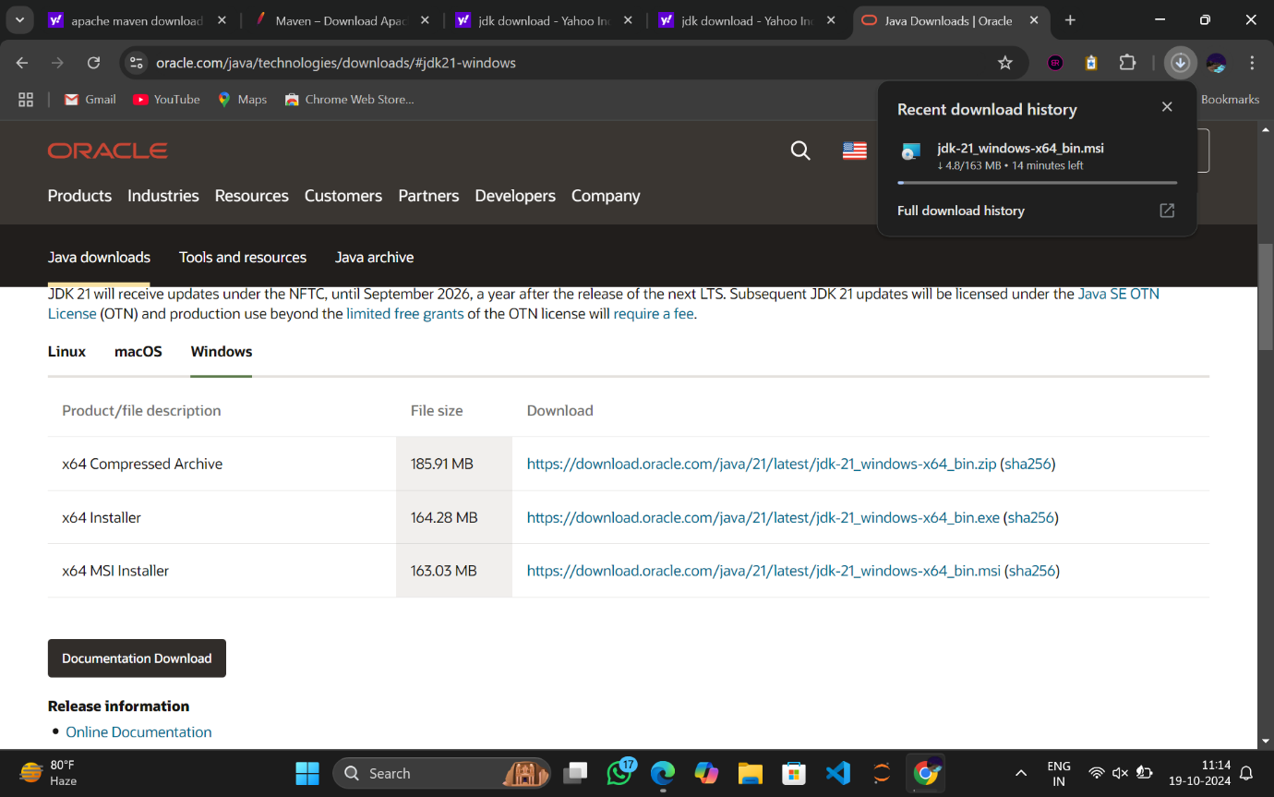

1. **Click on download to download JDK Version 21 and the exe starts getting downloaded**

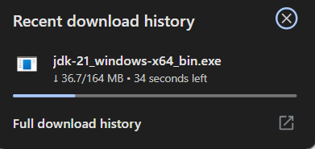

1. **The download is complete**

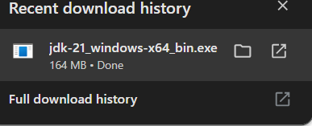

1. **Open the exe and click on next**

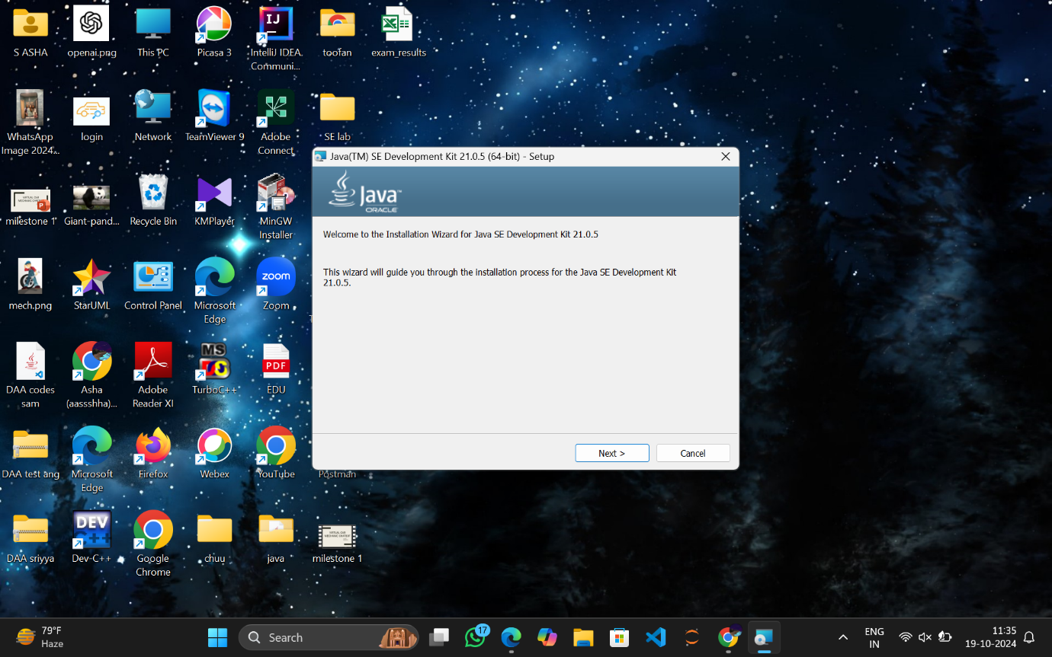

1. **Click Next**

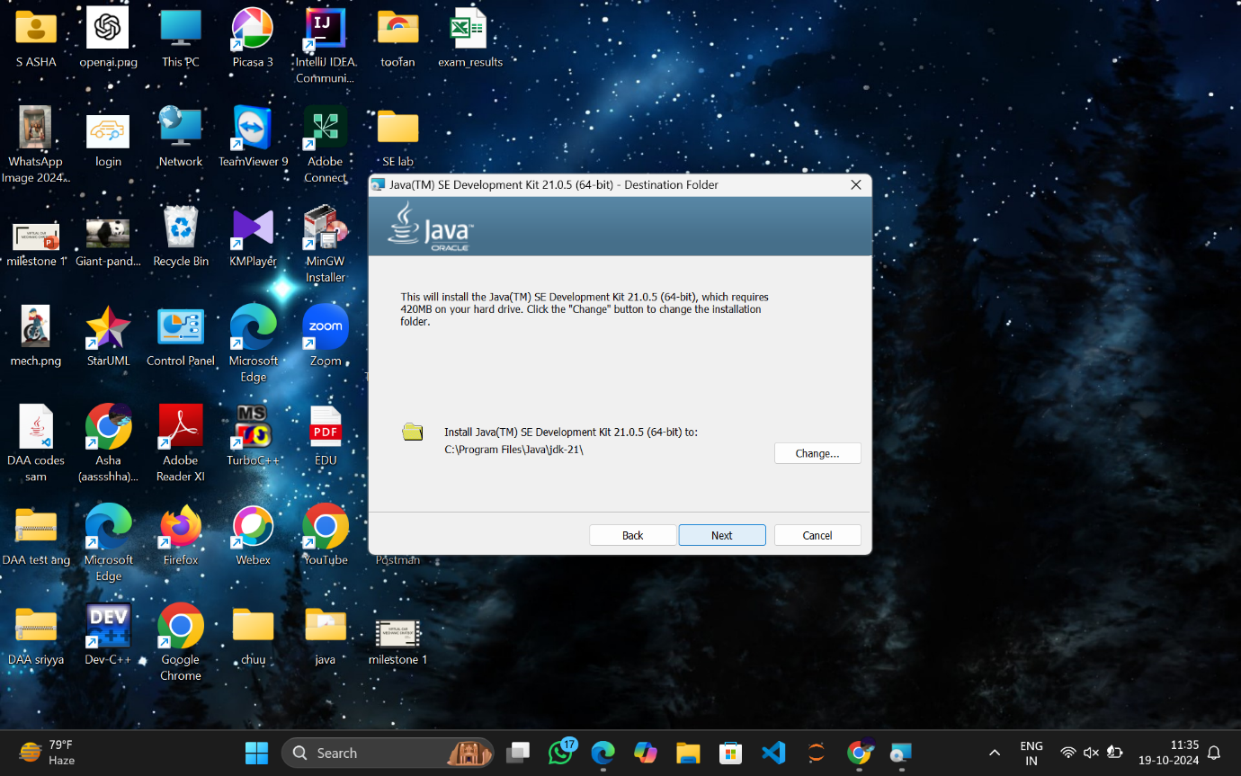

1. **Download is in progress**

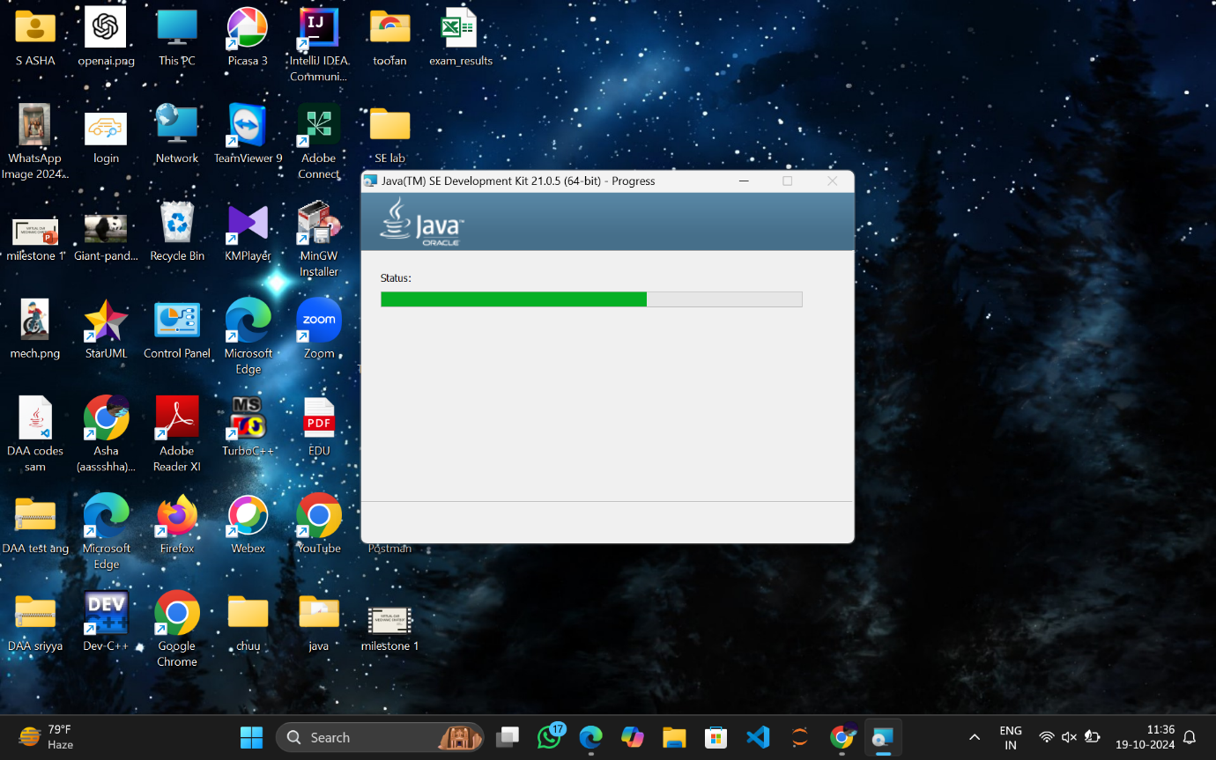

1. **Click on Close**

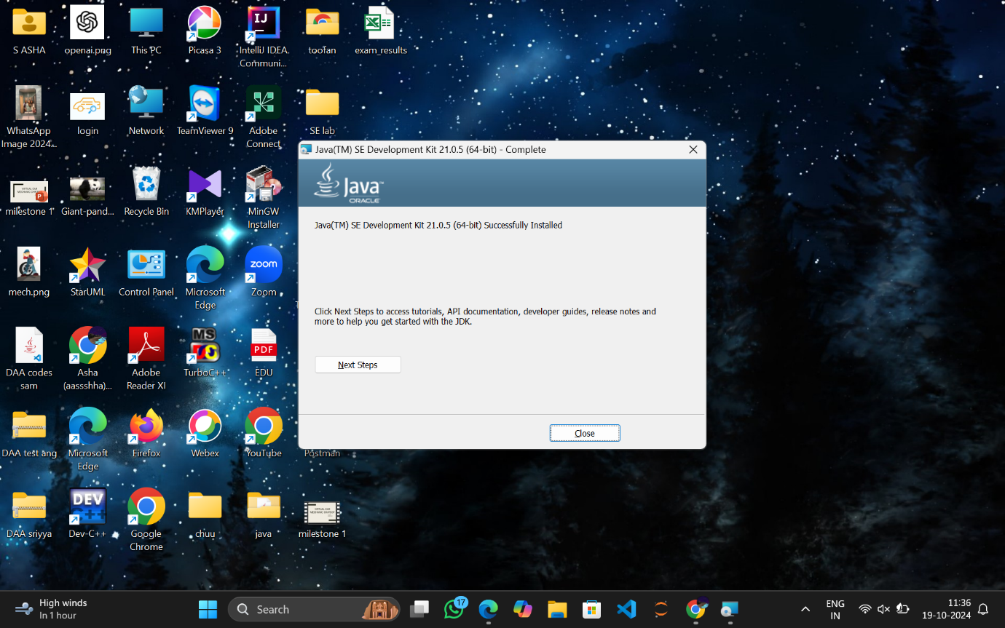

1. **Copy the path of the bin folder add in environment variables**

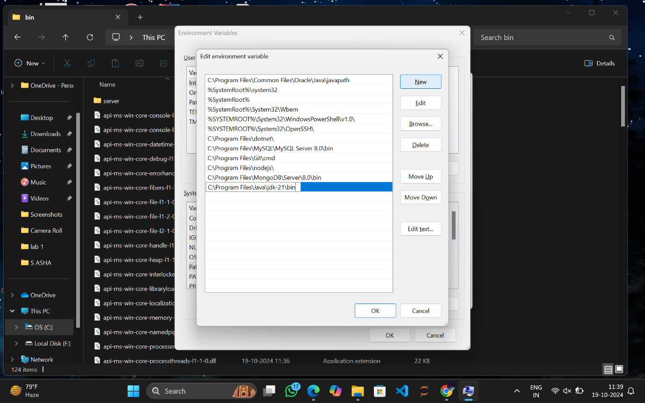

1. **Open command prompt and check java version**

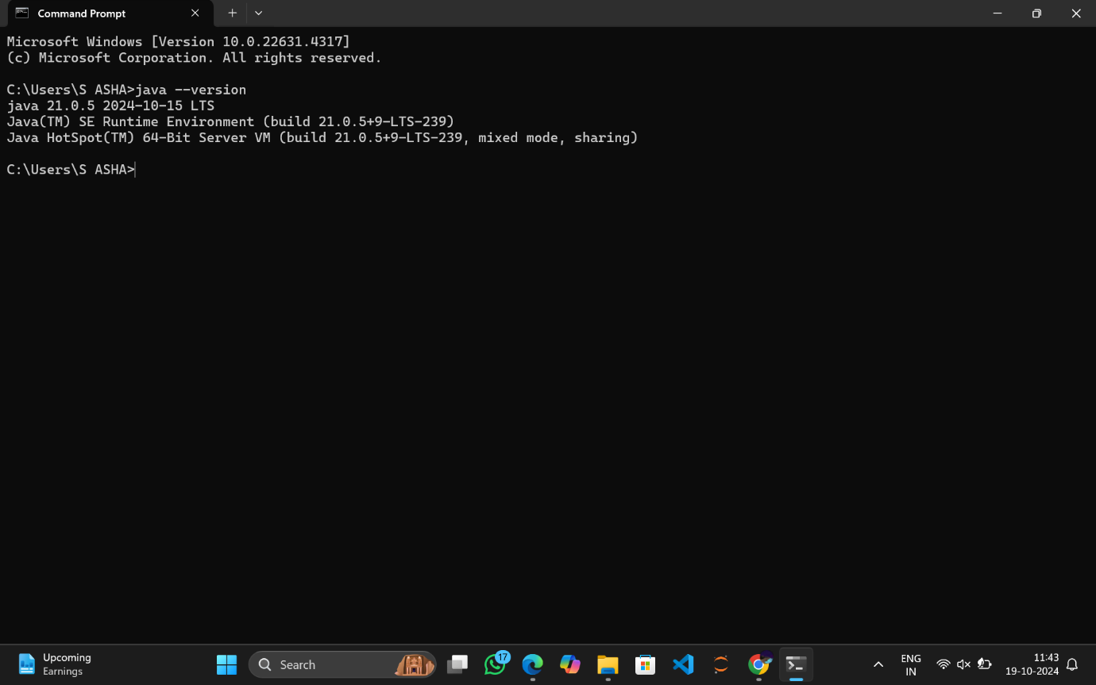

**And it is done!!!**

* **INSTALLATION OF MAVEN:**

1. **Go to Google type download maven and click on download Apache maven**

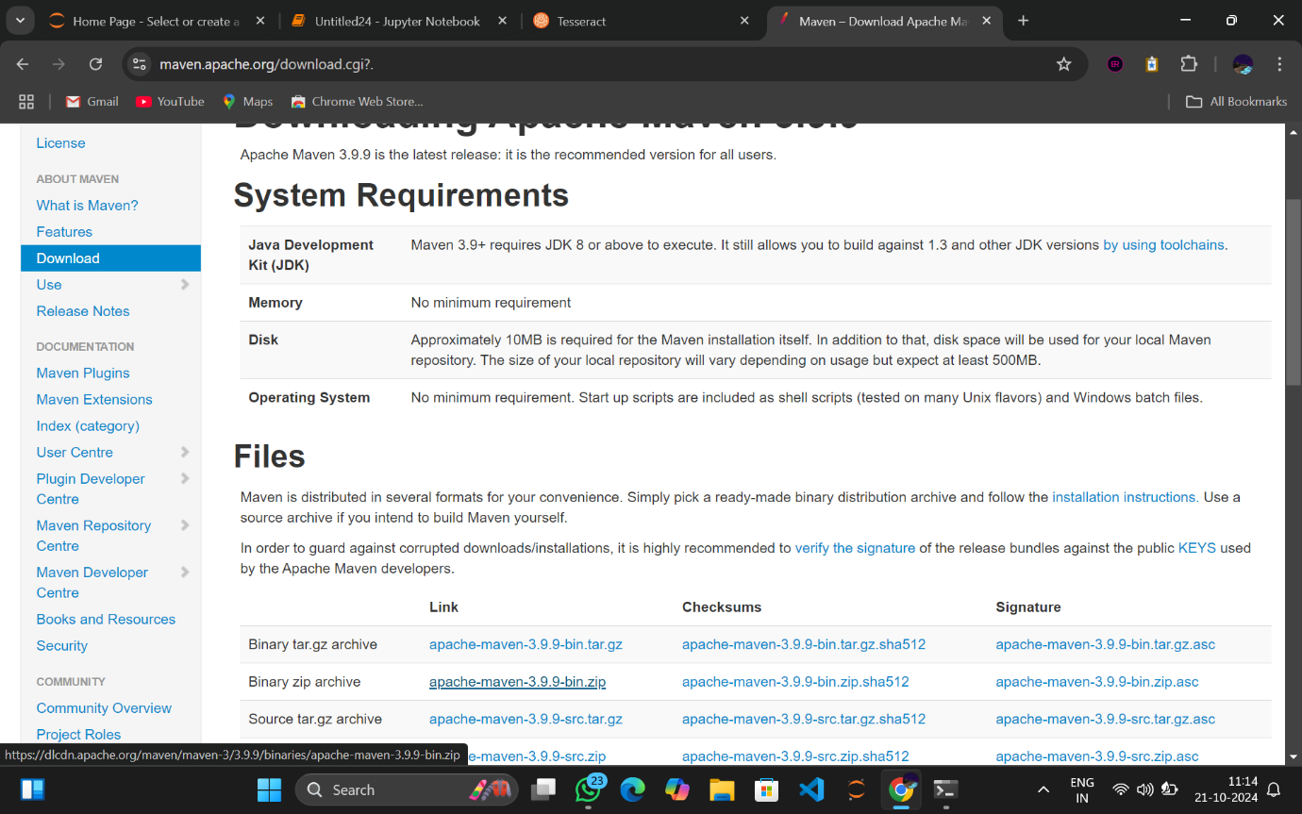

1. **THE ZIP FILE IS DOWNLOADED**

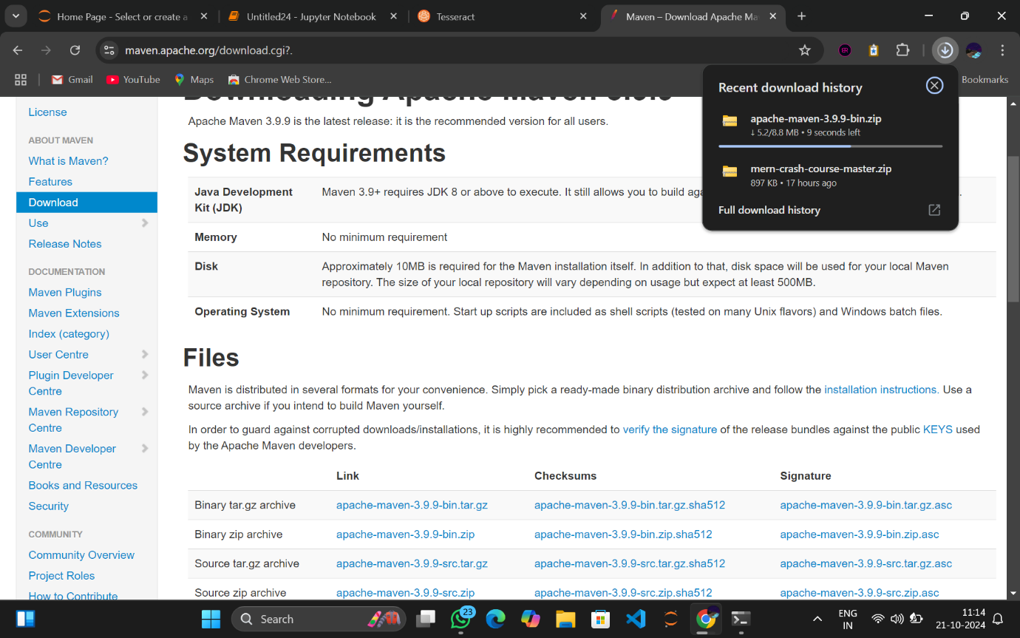

1. **OPEN THE FILE**

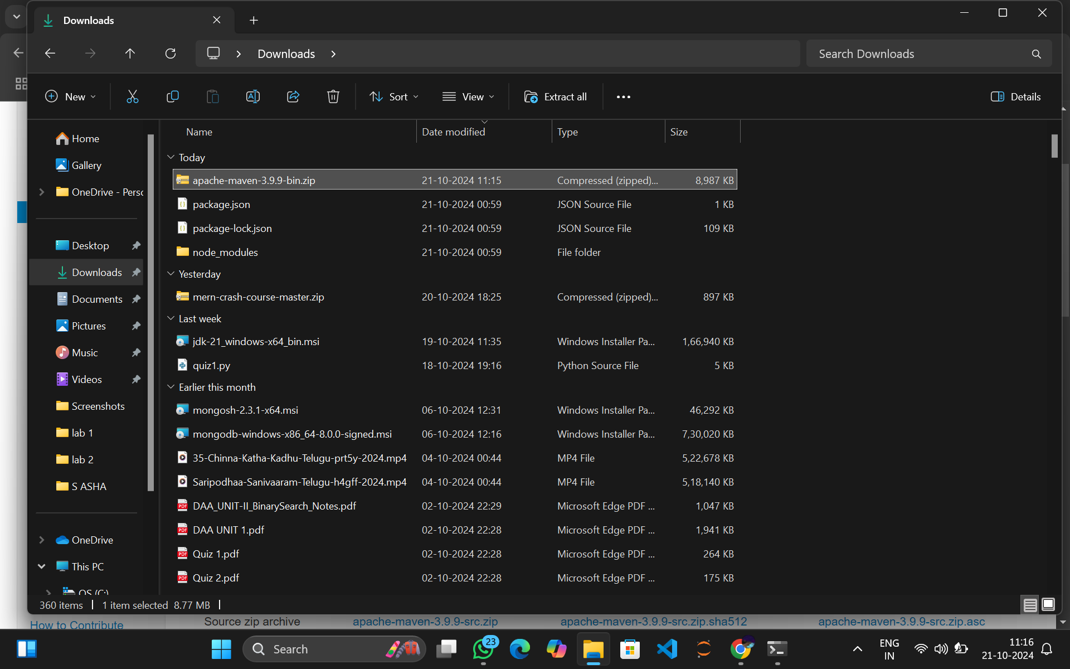

1. **CLICK ON EXTRACT ALL**

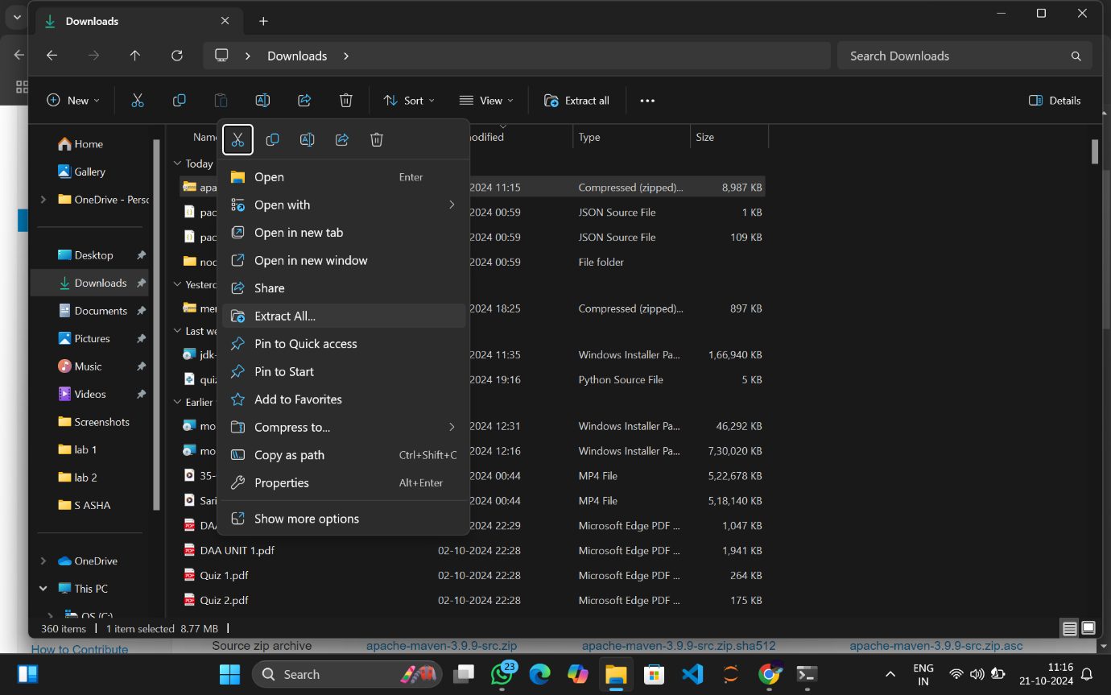

1. **SELECT LOCATION AND CLICK ON EXTRACT**

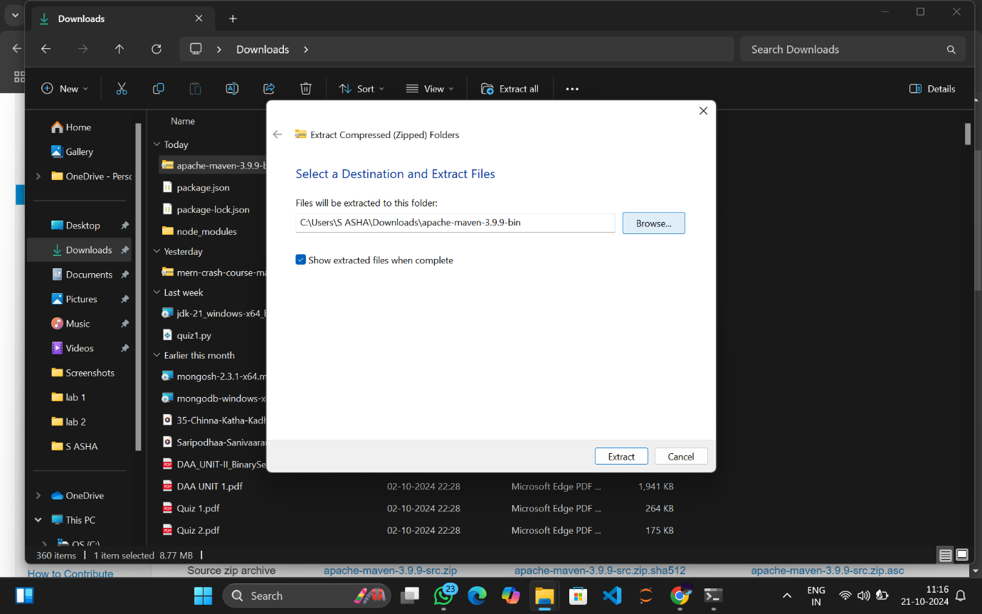

1. **EXTRACTION IS IN PROGRESS**

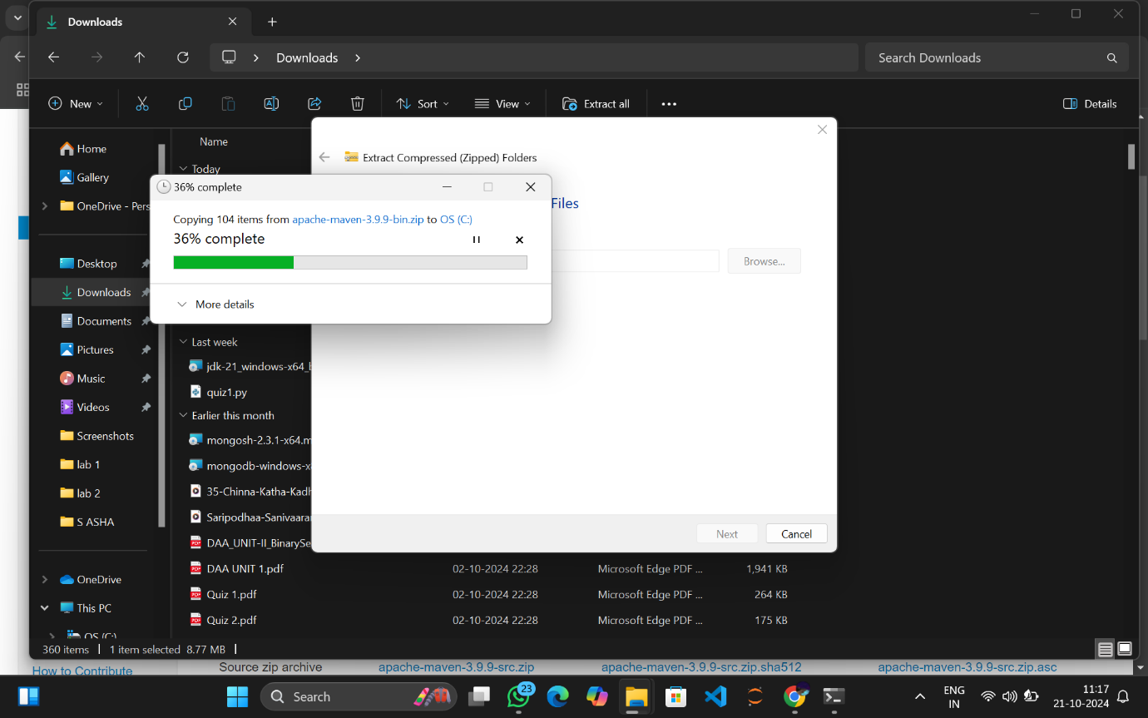

1. **EXTRACTION IS COMPLETED**

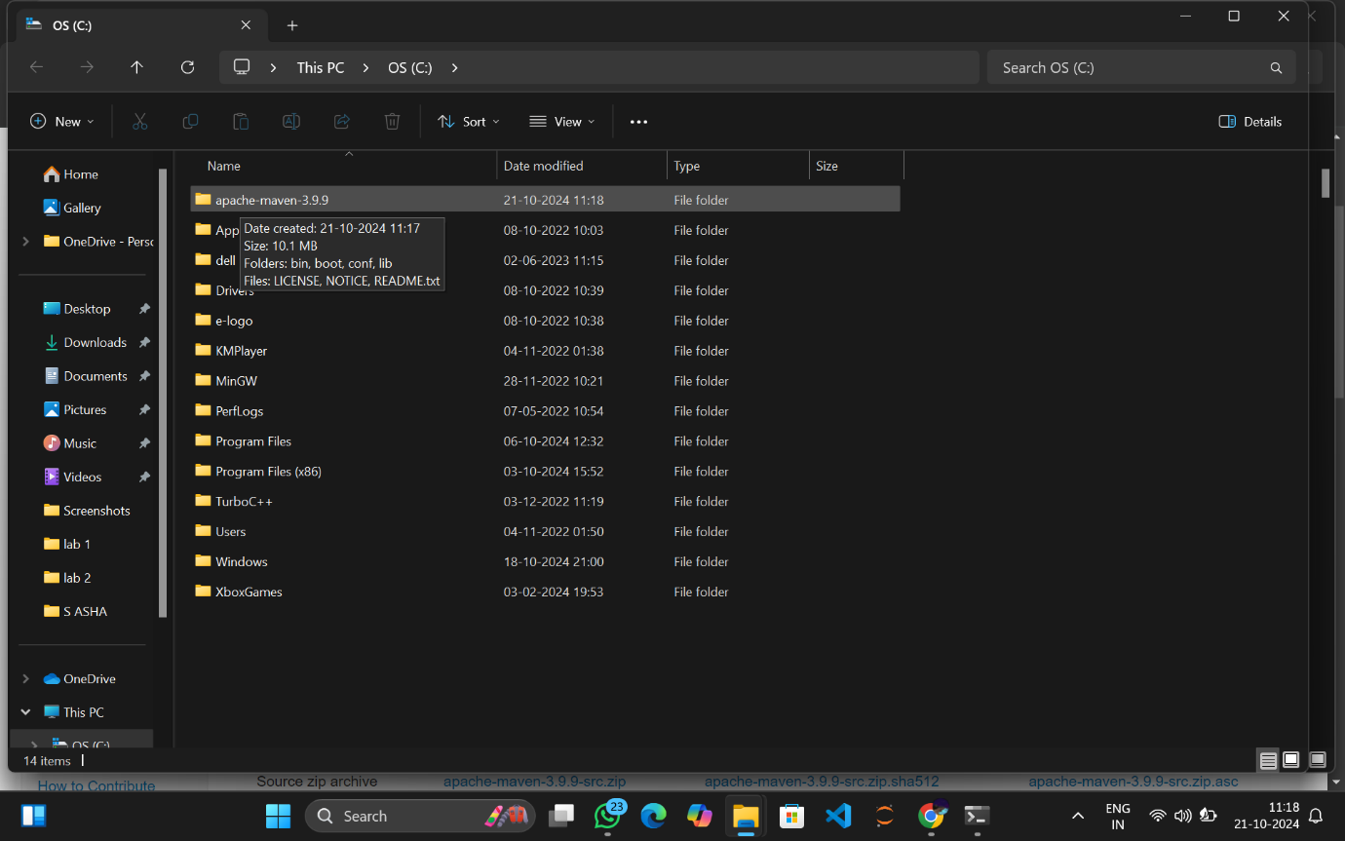

1. **COPY THE PATH OF THE BIN FOLDER AND ADD IN ENVIRONMENT VARIABLES**

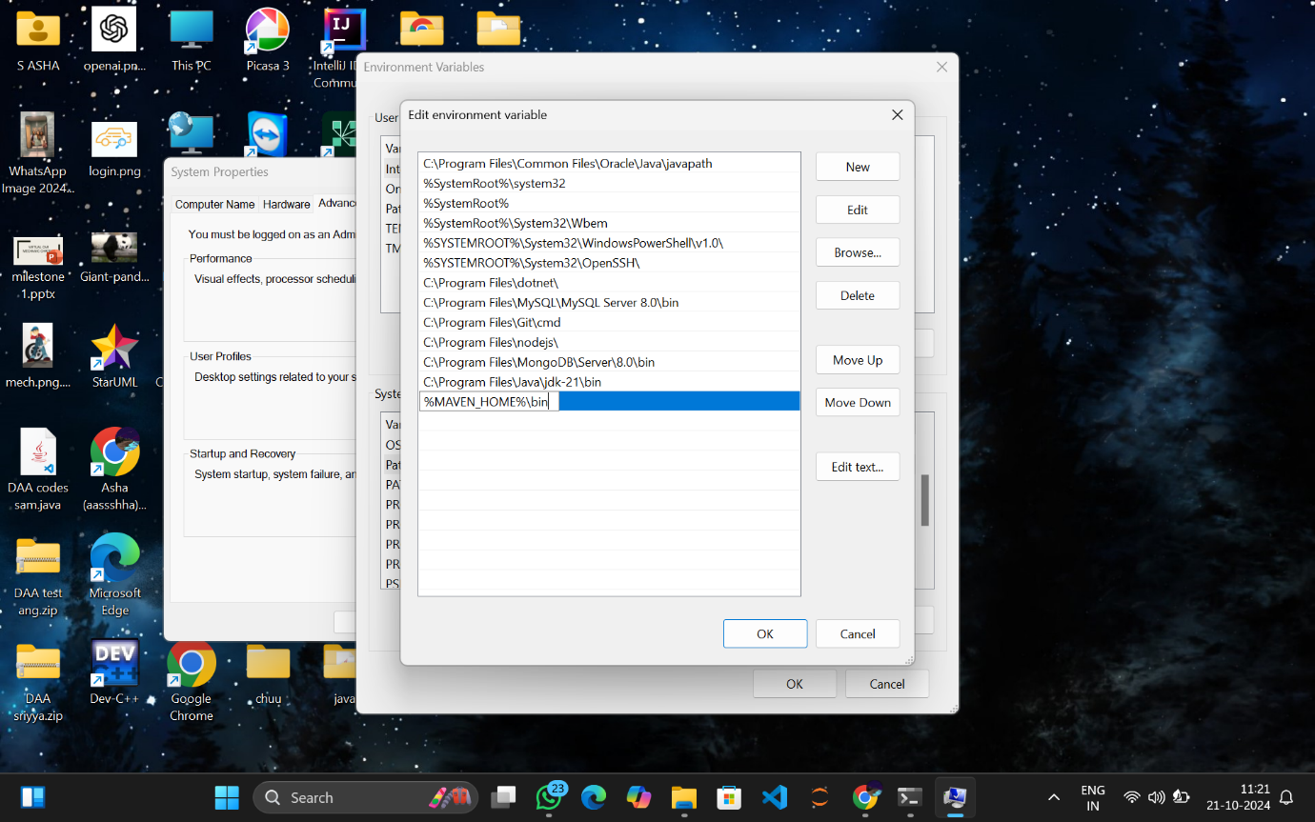

1. **GO TO COMMAND PROMPT AND CHECK MAVEN**

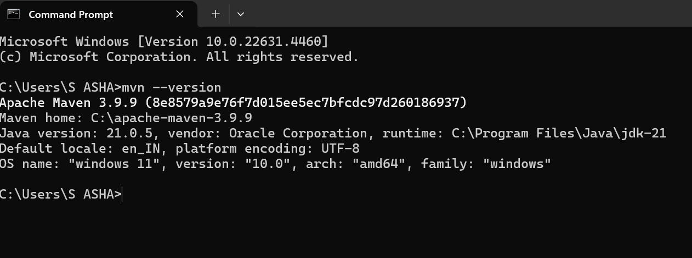

**AND INSTALLATION IS SUCCESSFUL!!!**

* **INSTALLATION OF TOMACT:**

1. **VISIT THE OFFICIAL APACHE TOMCAT WEBSITE**

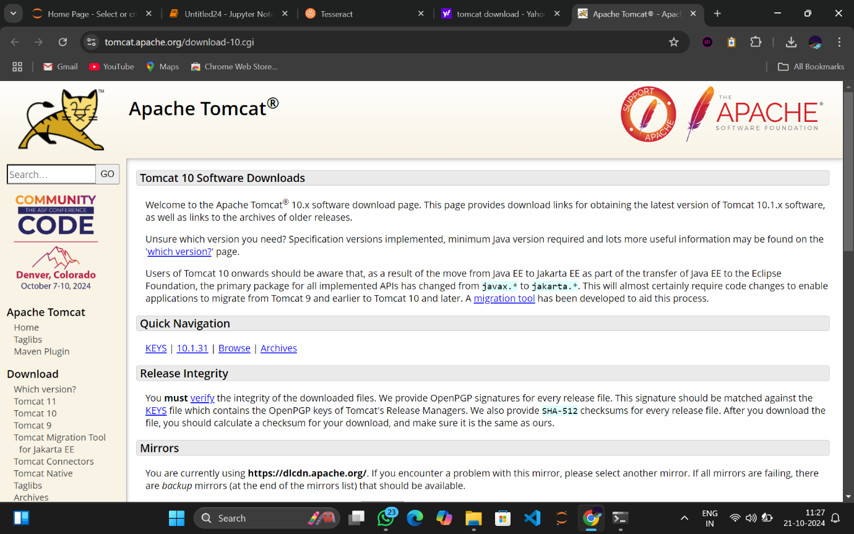

1. **Click on the following link 64-bit windows zip to download the zip file**

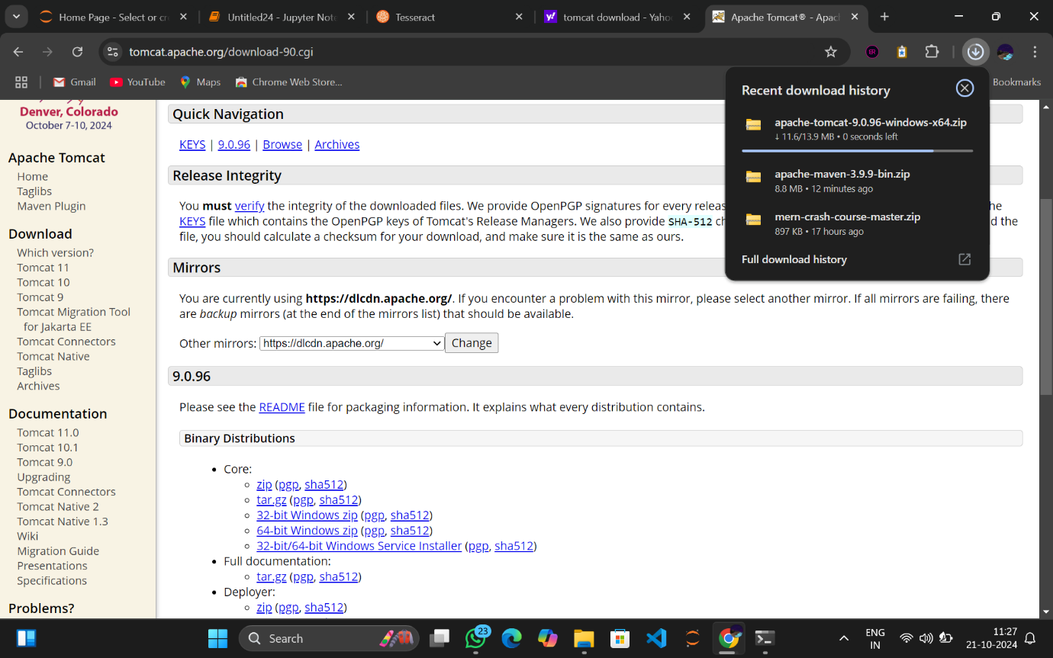

1. **GO TO DOWNLOADS AND UNZIP THE FILE**

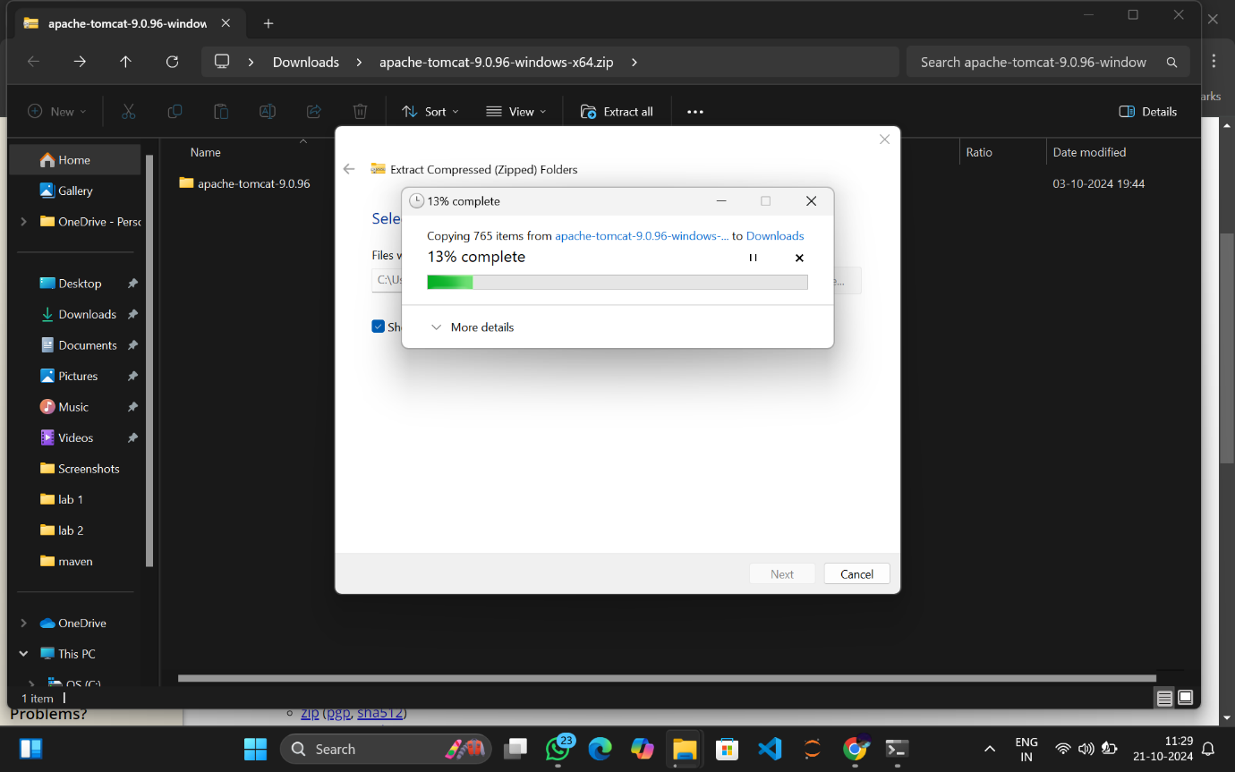

1. **Here are the unzipped files**

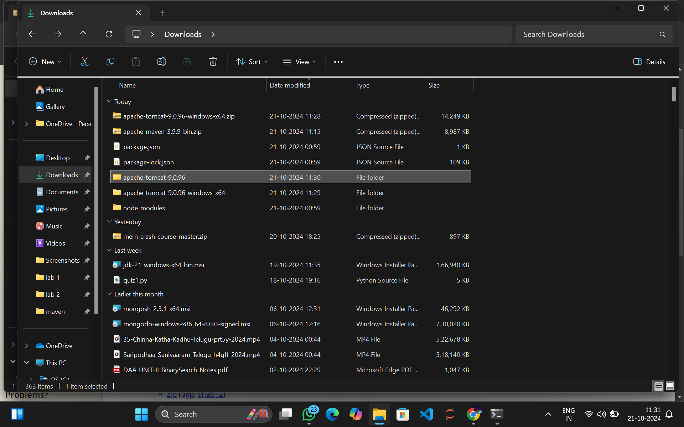

**And we are done with its installation!!!!**

* **INSTALLATION OF ECLIPSE:**

1. **Visit the official eclipse website**

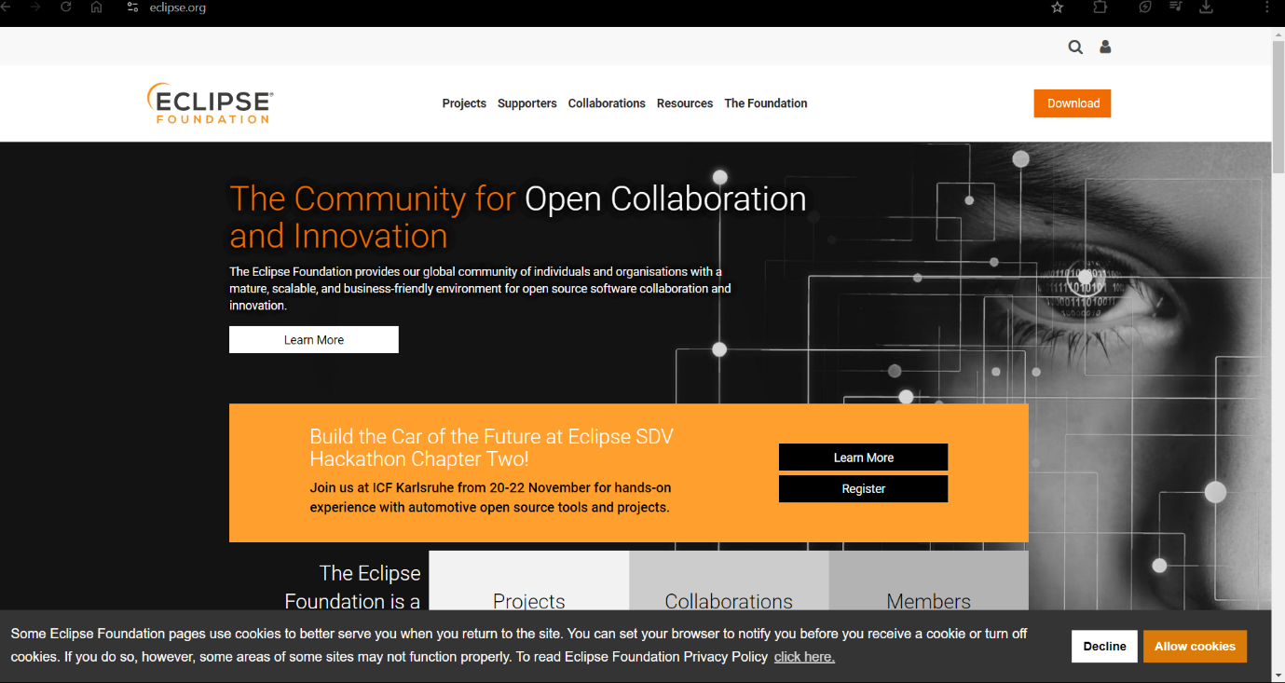

1. **Click on download**

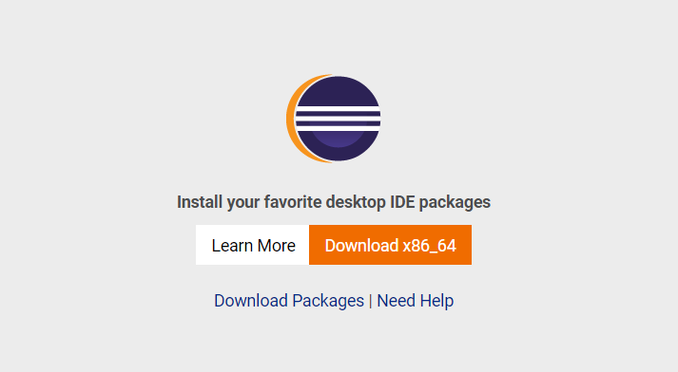

1. **Download the win64.exe file**

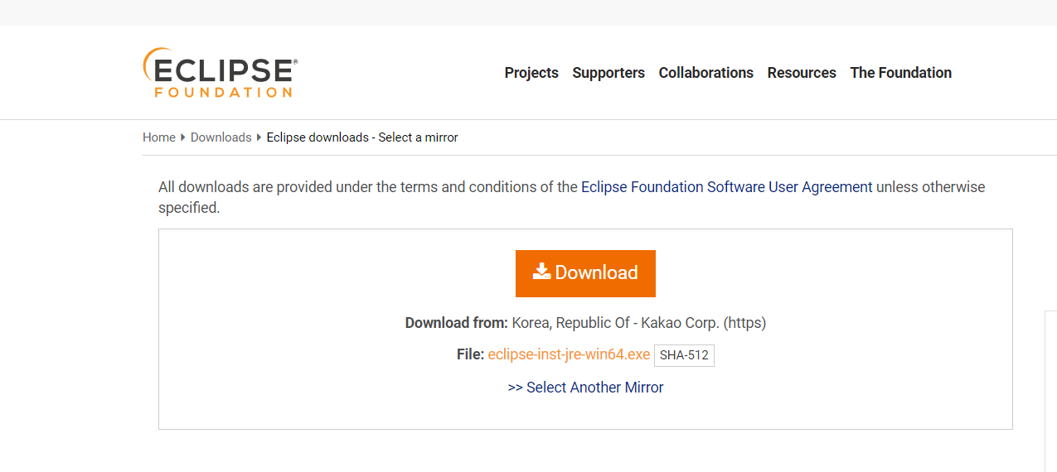

1. **Installation is completed**

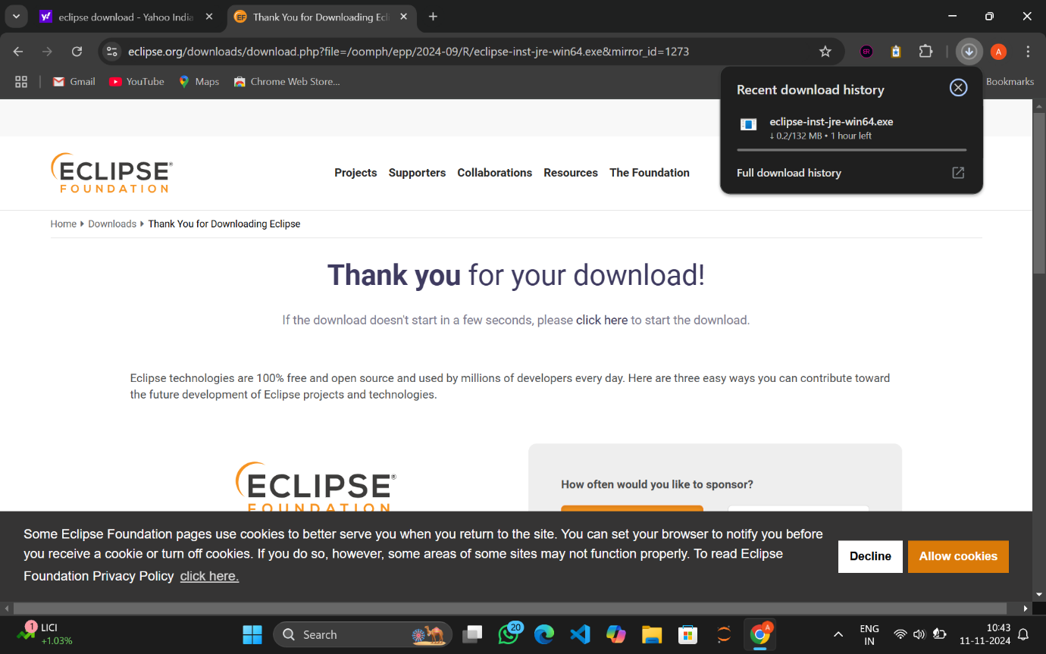

1. **Click on the exe file and select the Second option**

**Eclipse IDE for Enterprise Java and wen development**

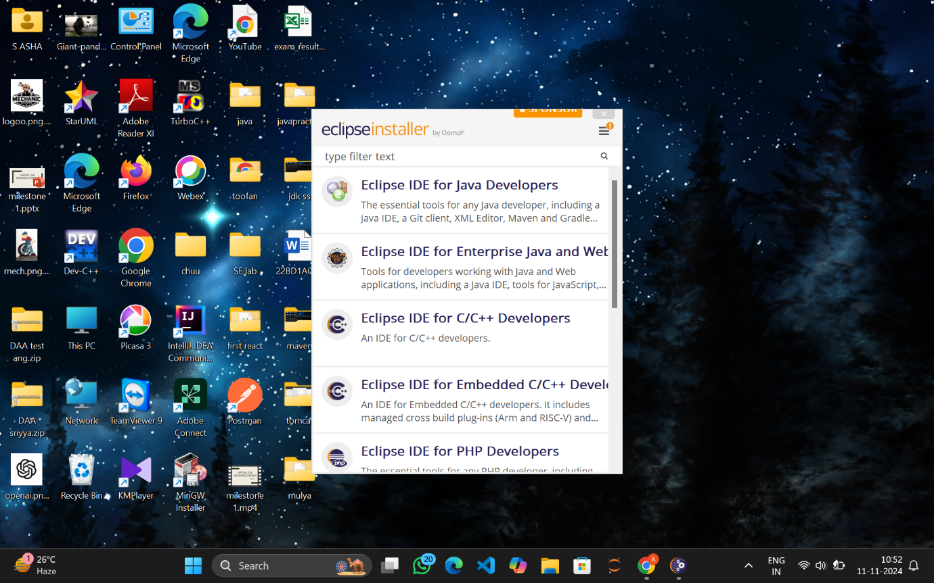

1. **Click on install**

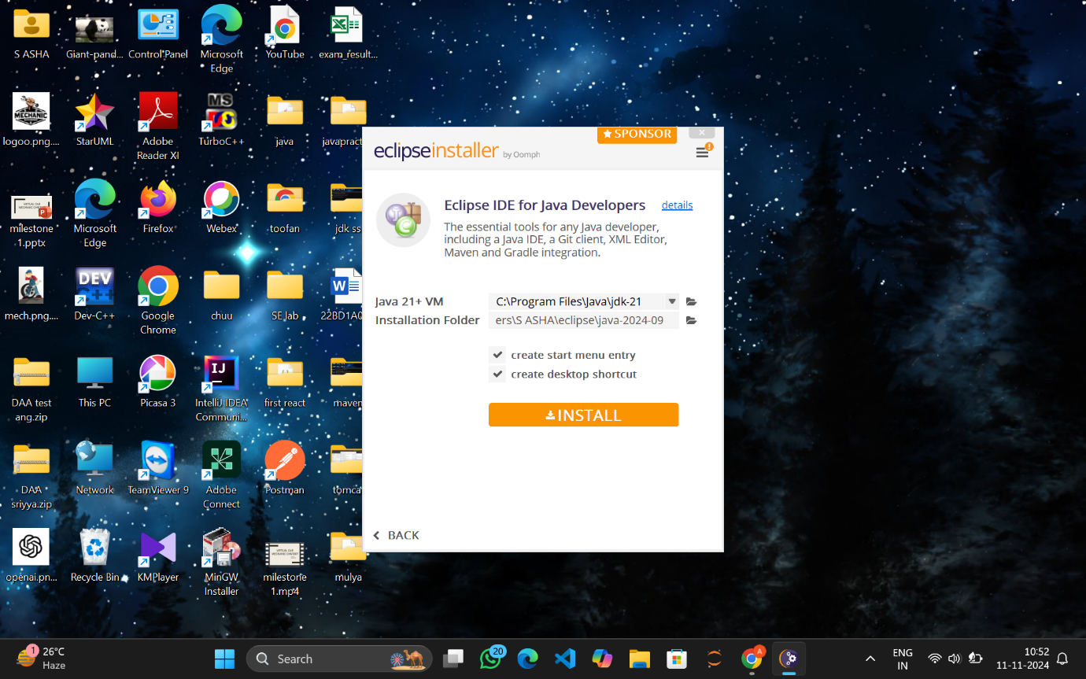

1. **Click on Accept now**

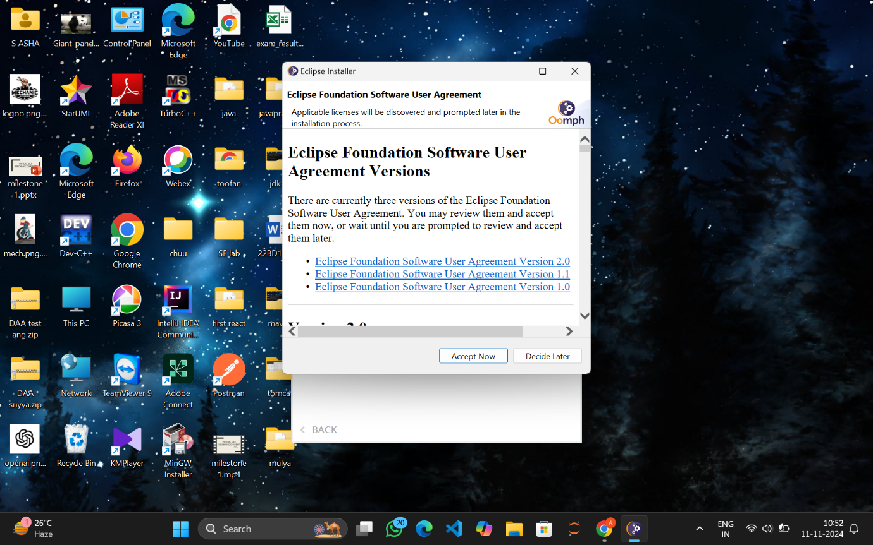

1. **Installation in progress**

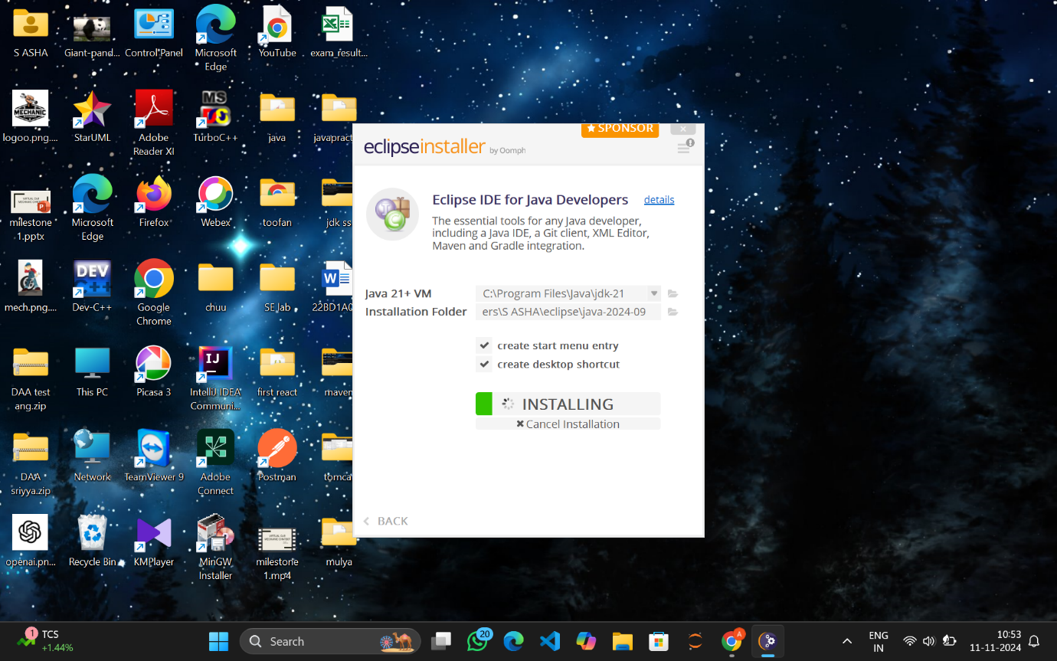

1. **Click on Launch**

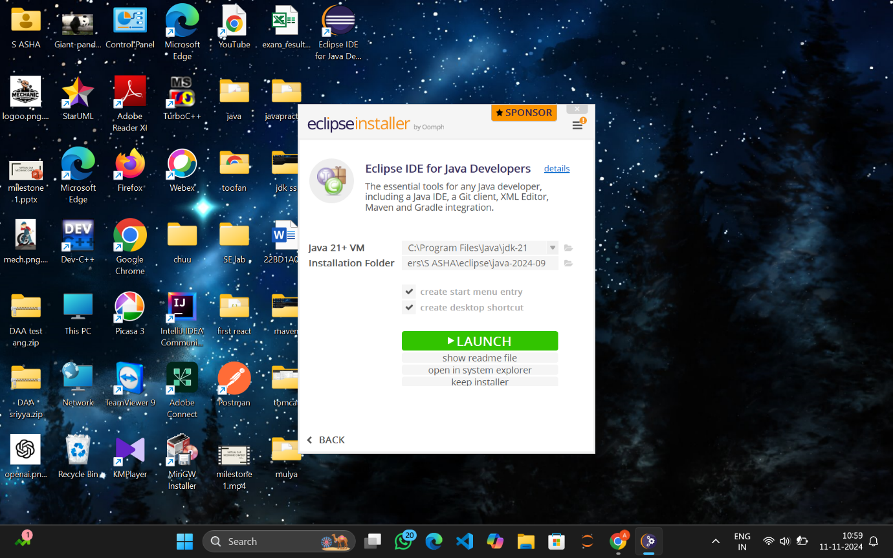

1. **Select directory and click launch**

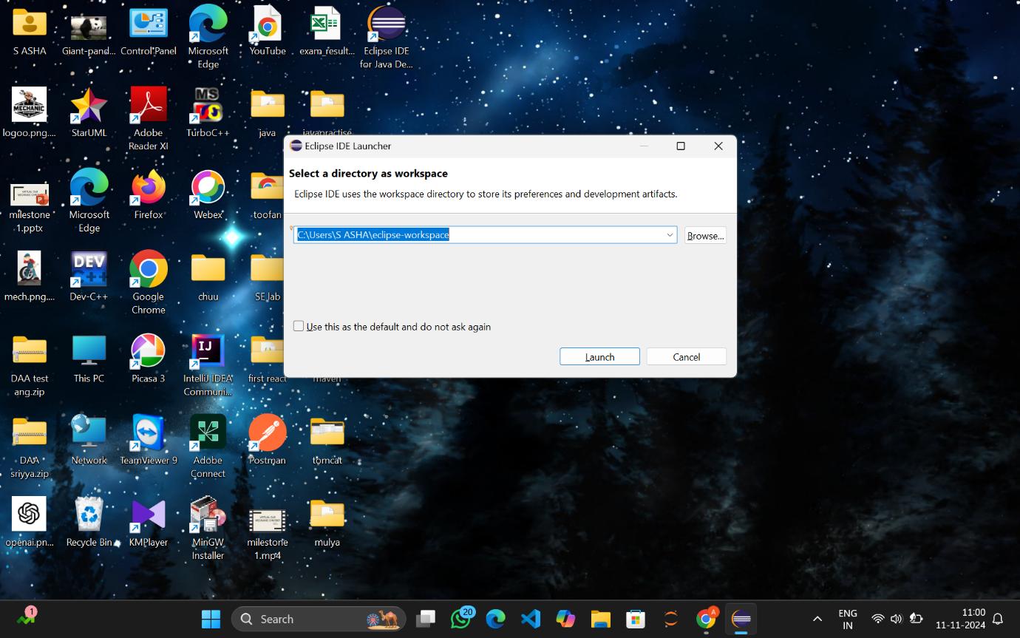

1. **Eclipse is ready to use**

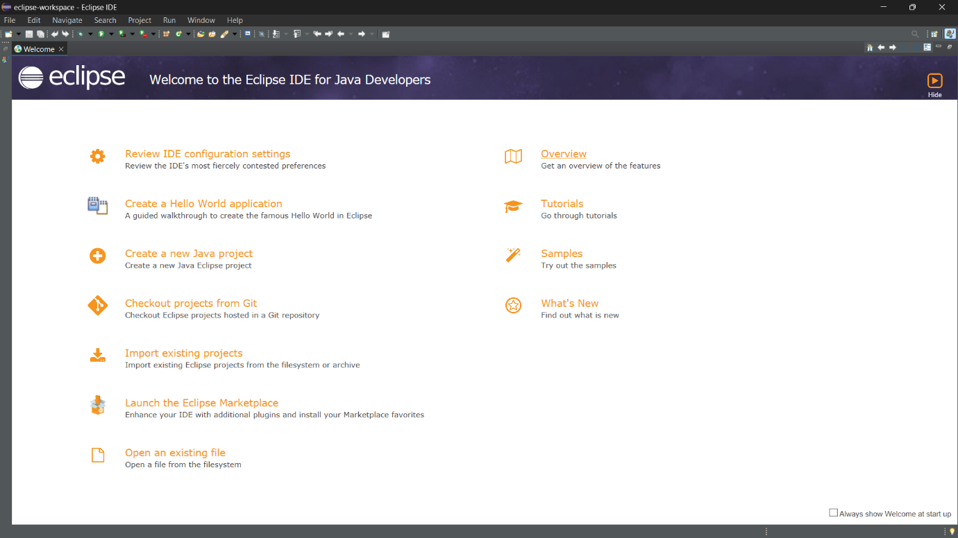

**CONFIGURING TOMCAT TO ECLIPSE:**

**Install updates into eclipse**

**Click on Help->Install new software**

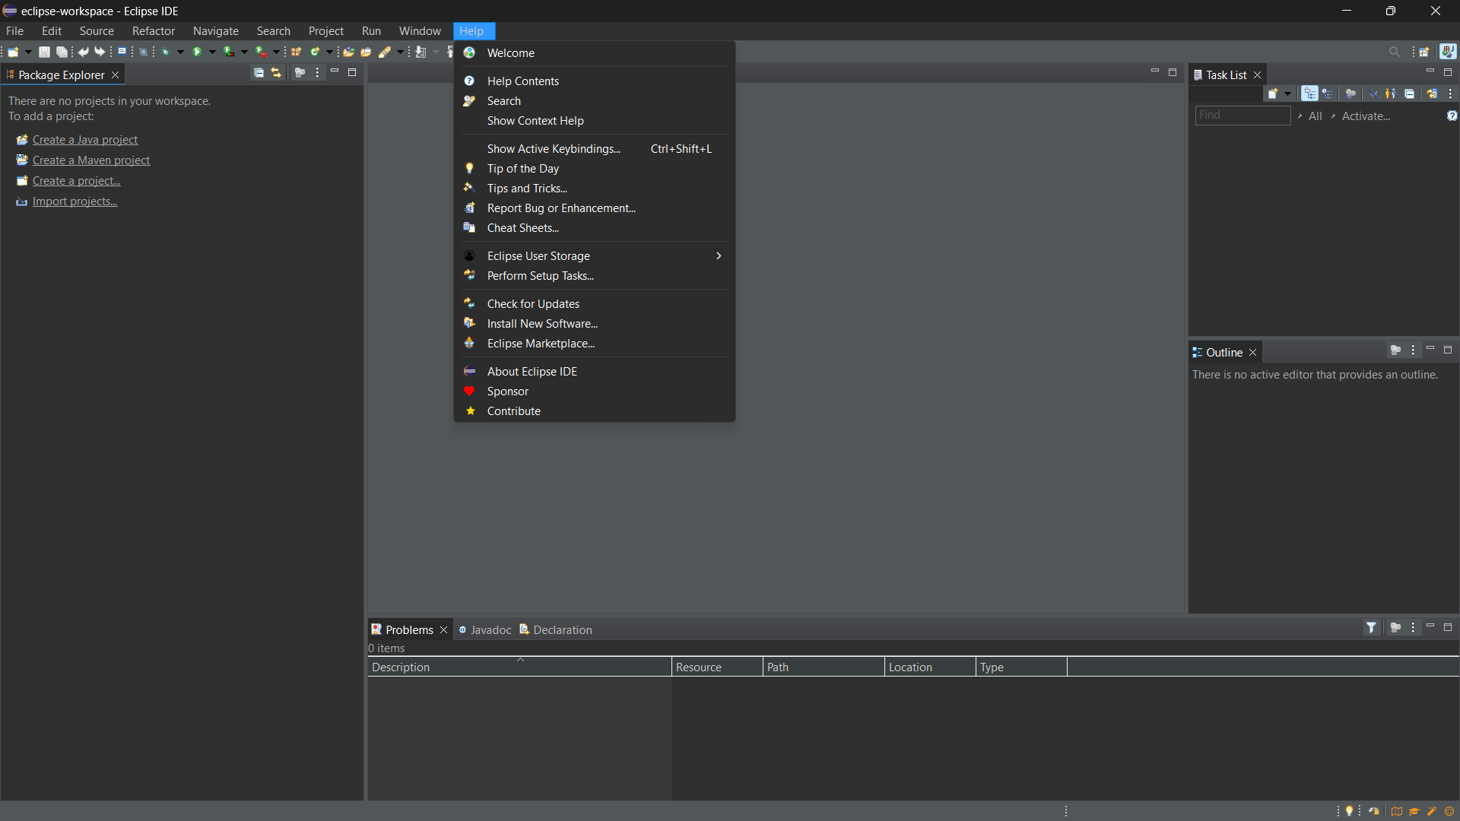

**Before installing server into eclipse, we need to add Java EE to the eclipse IDE**

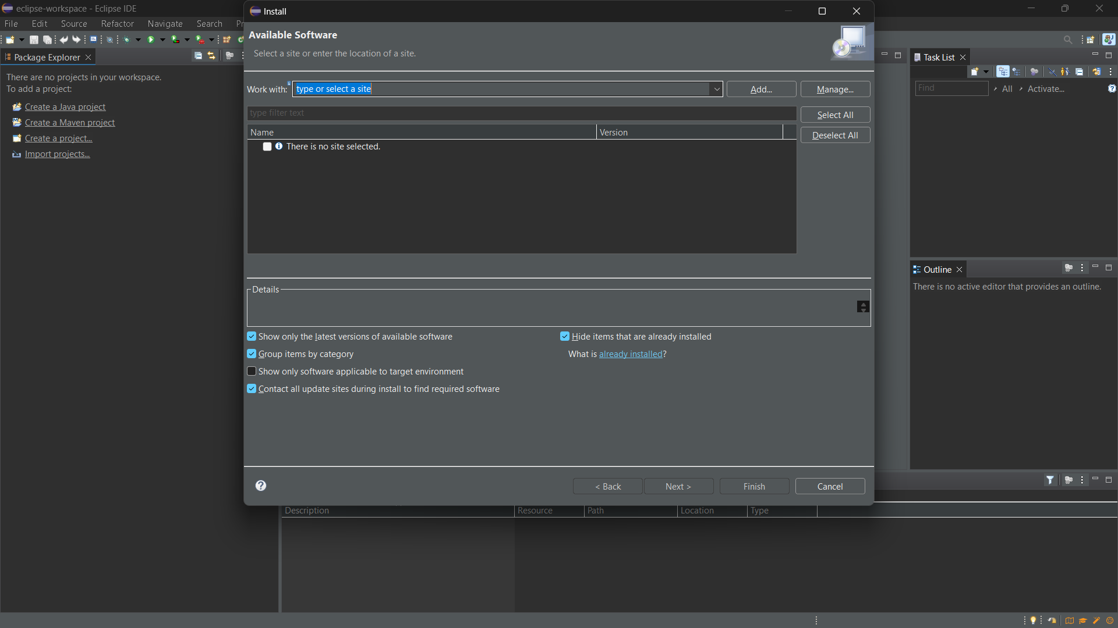

**Click on the drop down menu in Work with and select the following from the list**

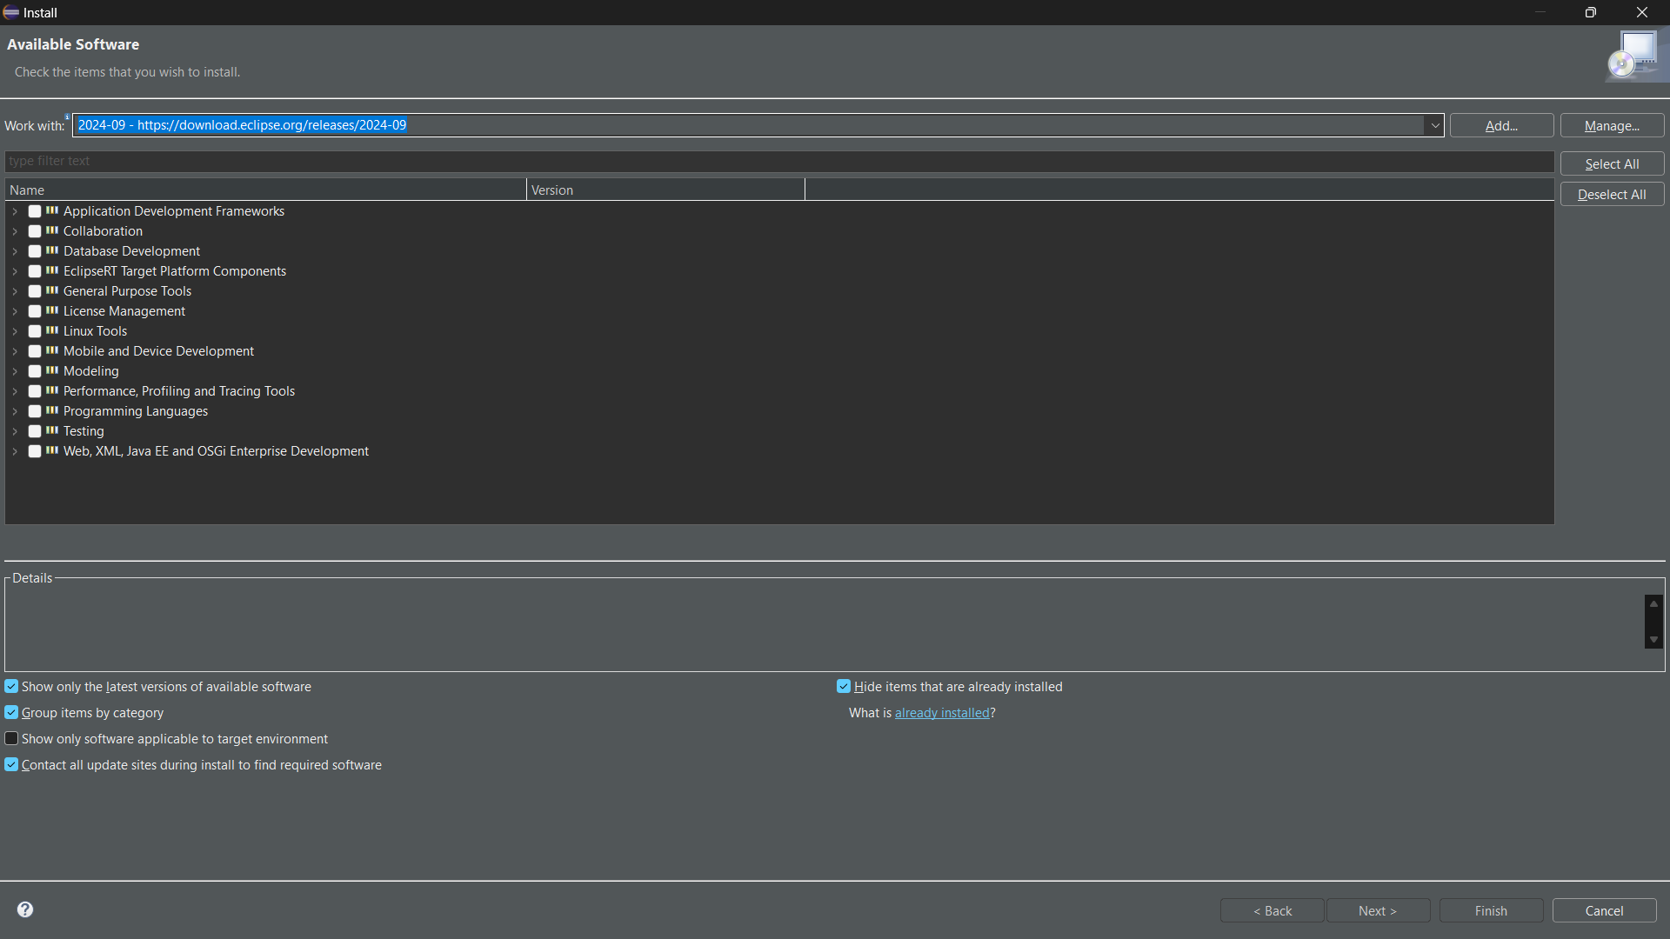

**Check the Web,XML,JAVA EE box to install the latest software**

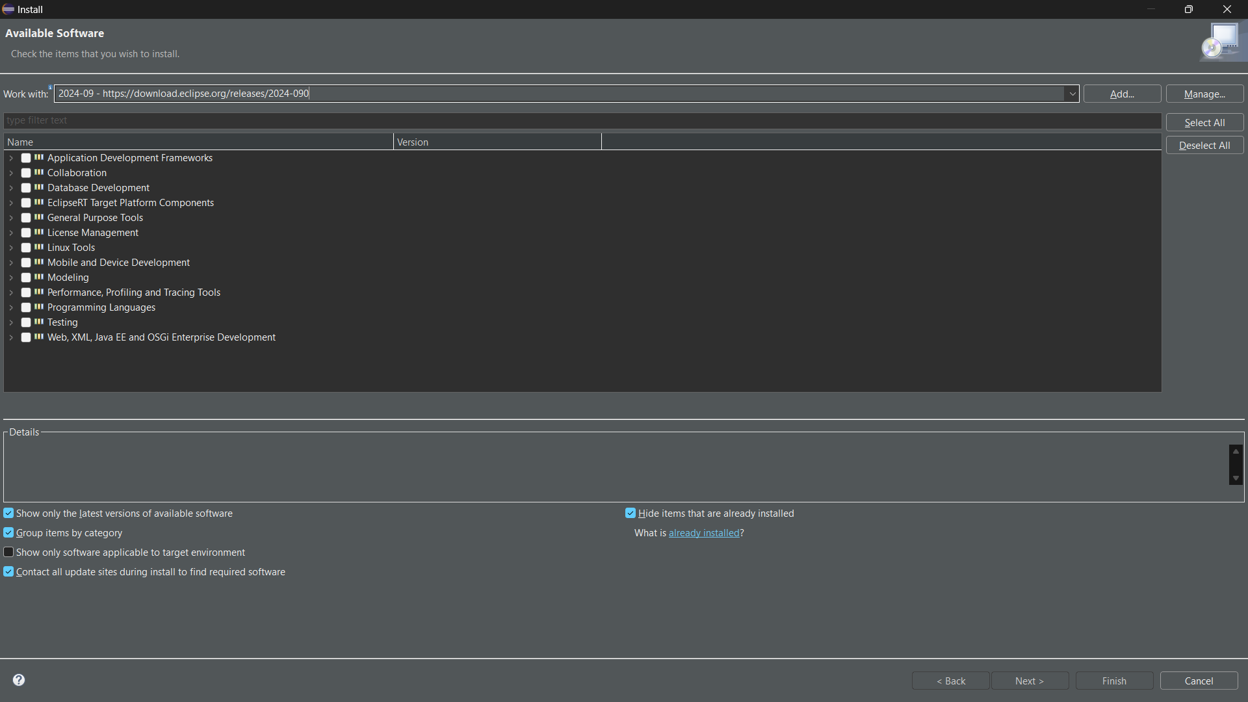

**Since we develop only Maven web project in DevOps, we can only check the shown two and click on next**

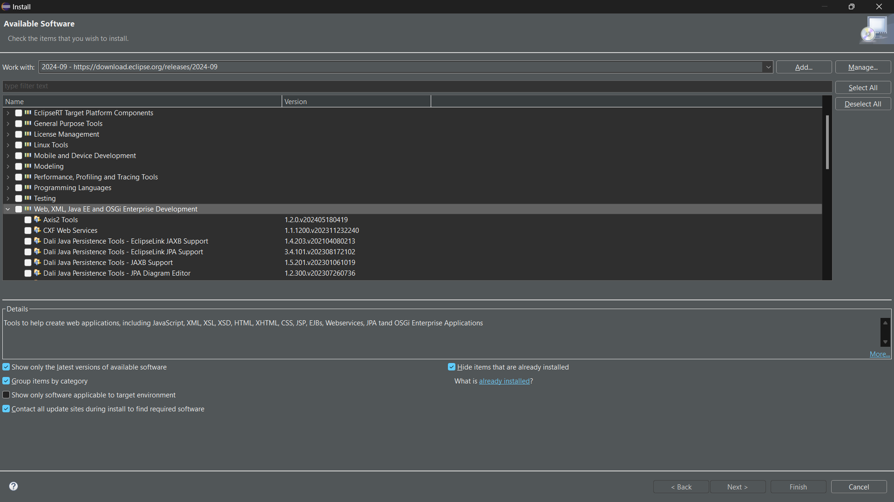

**Here enable the JST Adapter and JST server adapter**

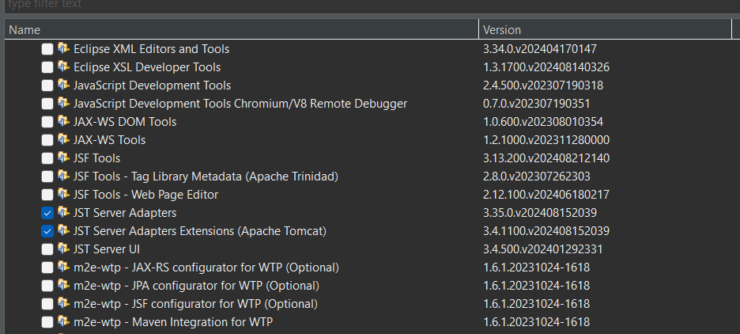

**Install them**

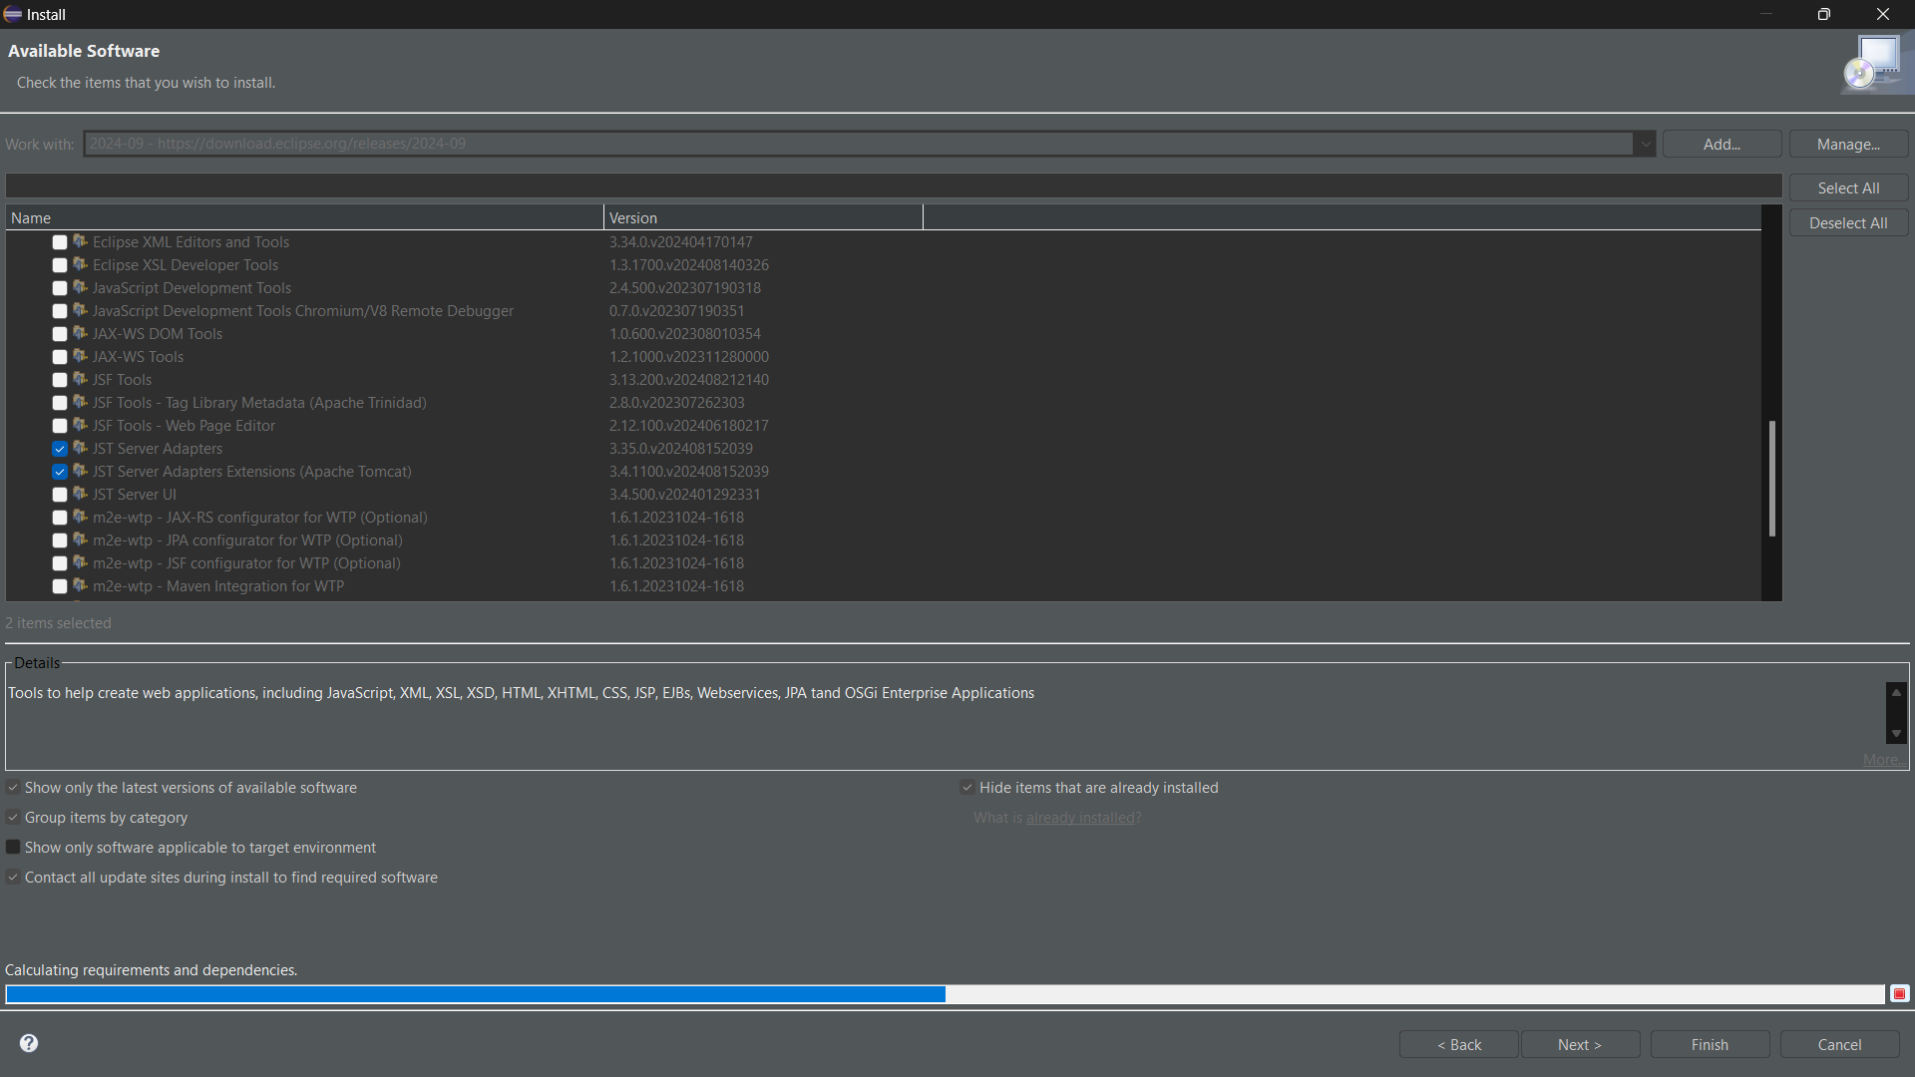

**Click on Next**

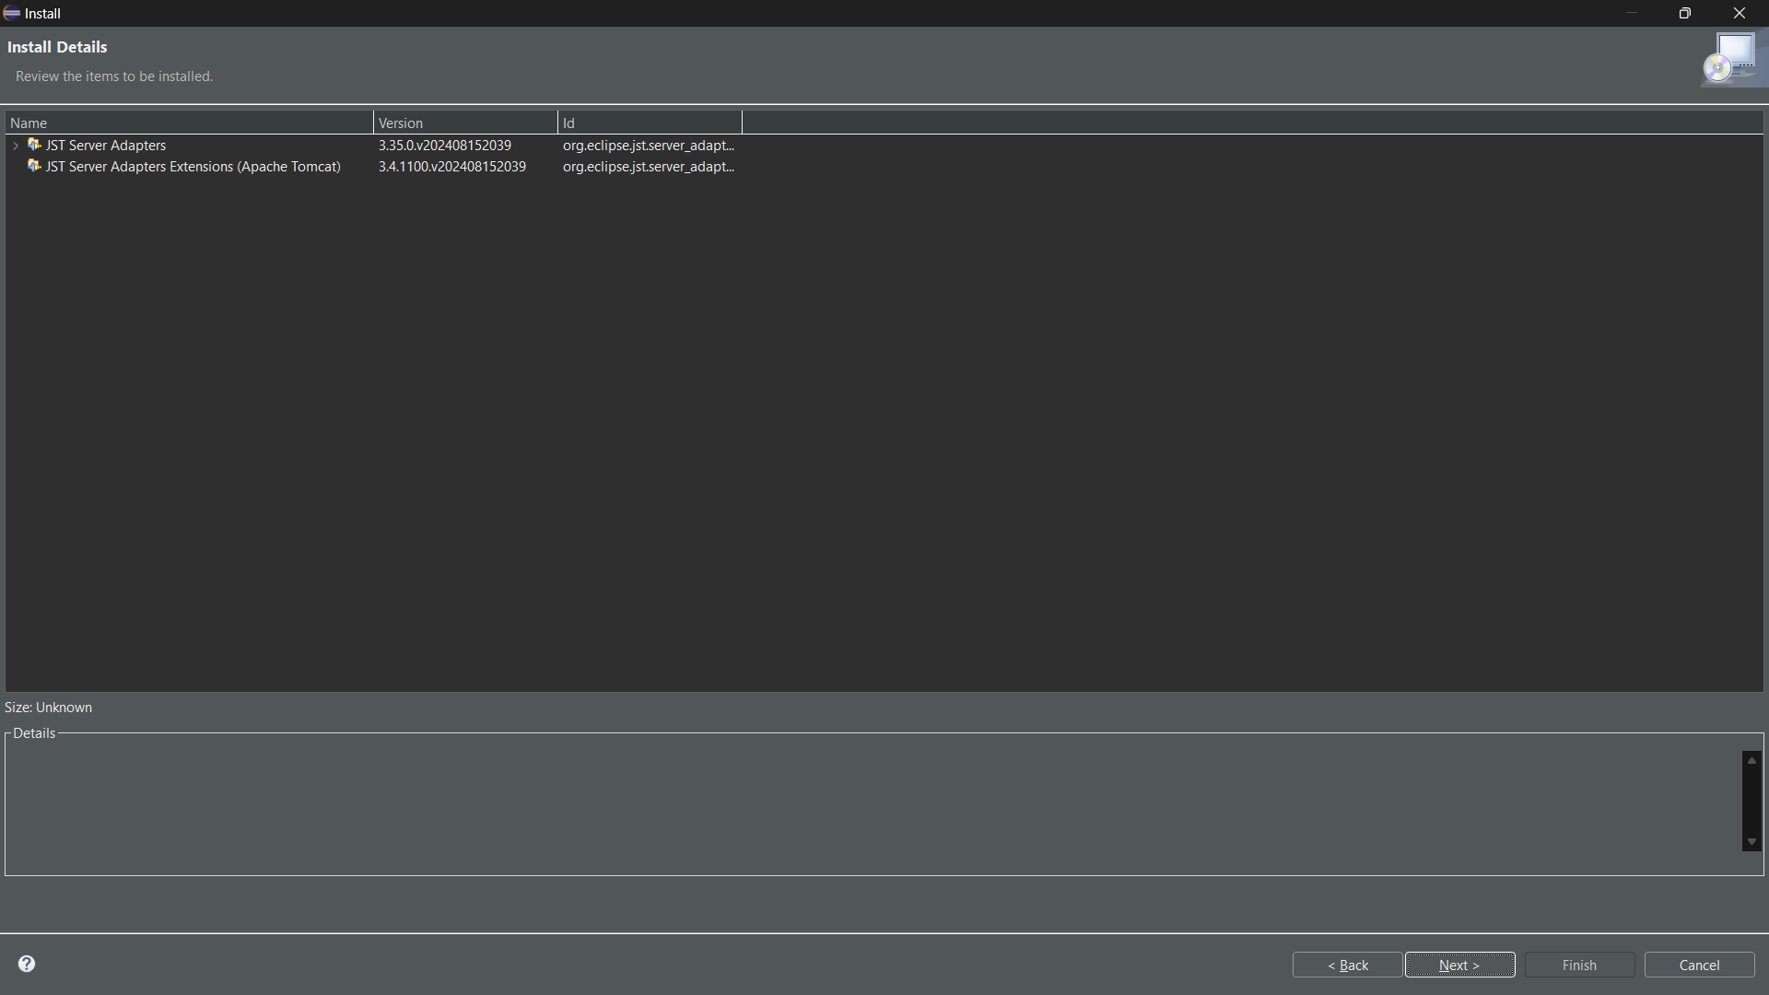

**Select I Accept->Finish**

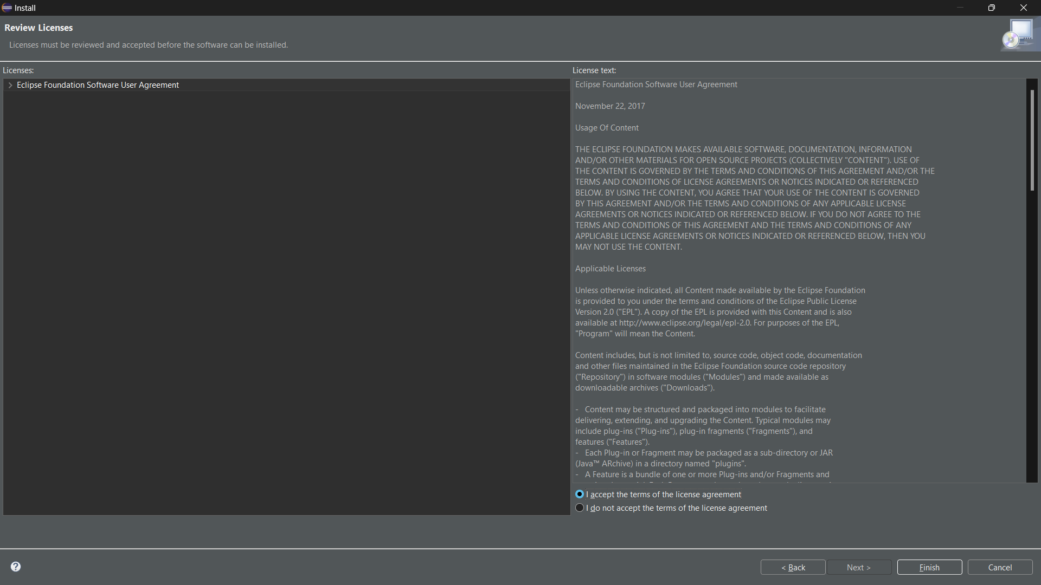

**Restart the eclipse IDE**

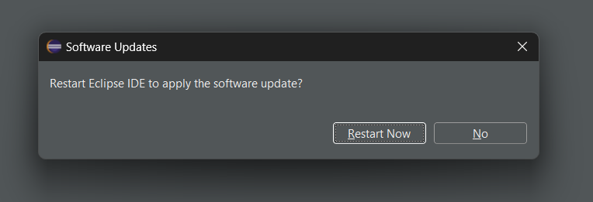

**After the shown installation, check whether server is available in eclipse as shown**

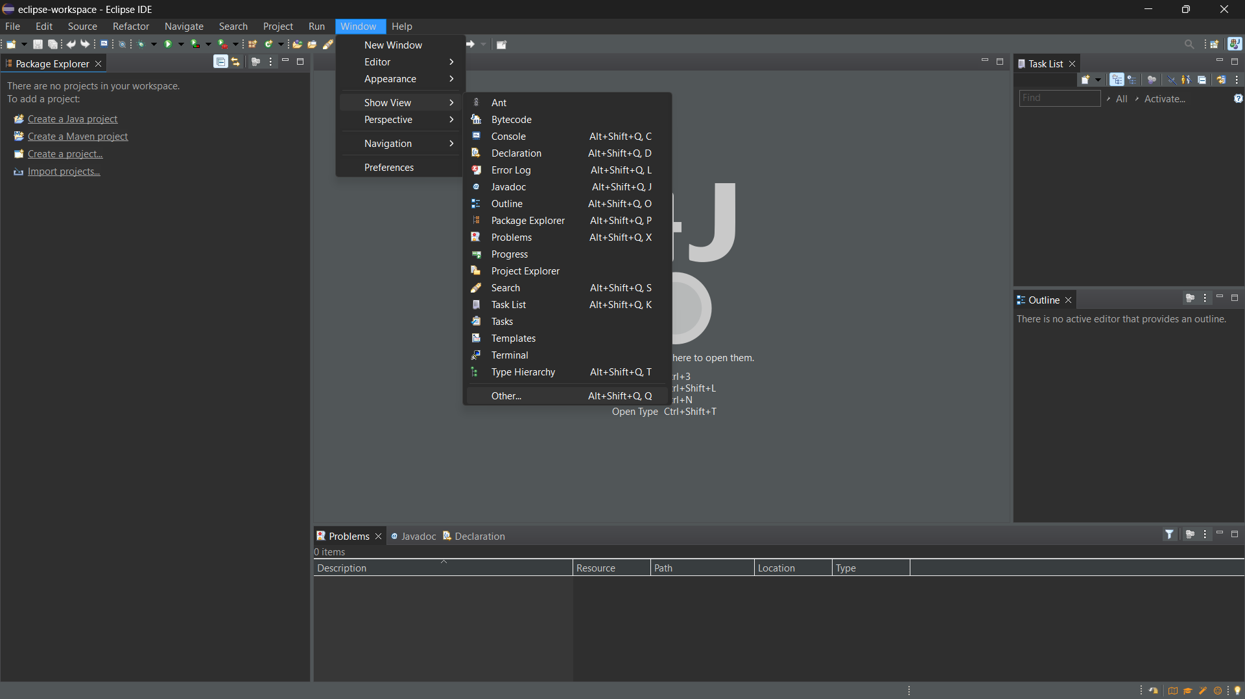

**In show view, we can now see Servers**

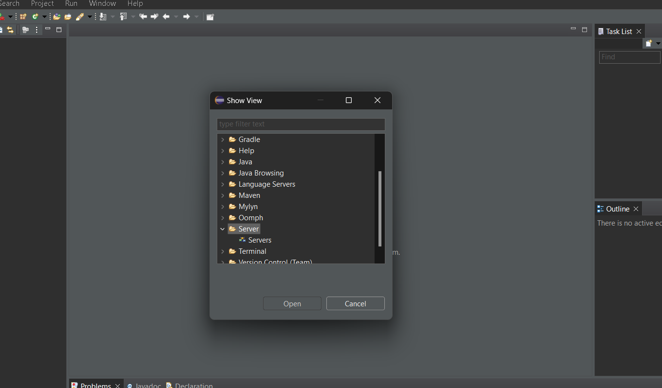

**Click on Apache Folder**

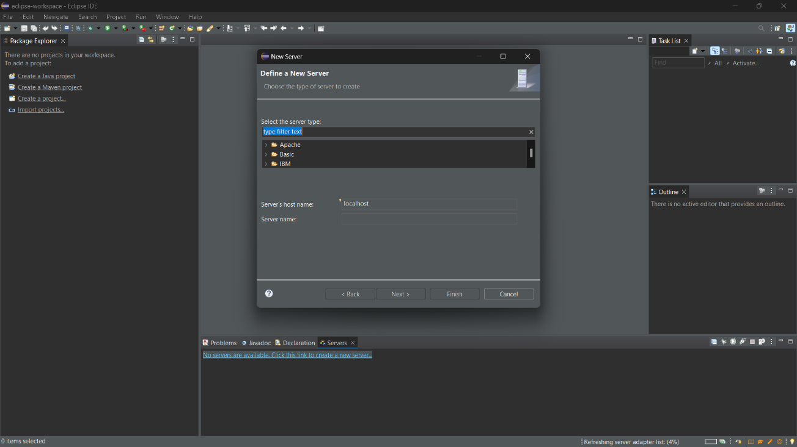

**Select Tomacat V9 server and click Next**

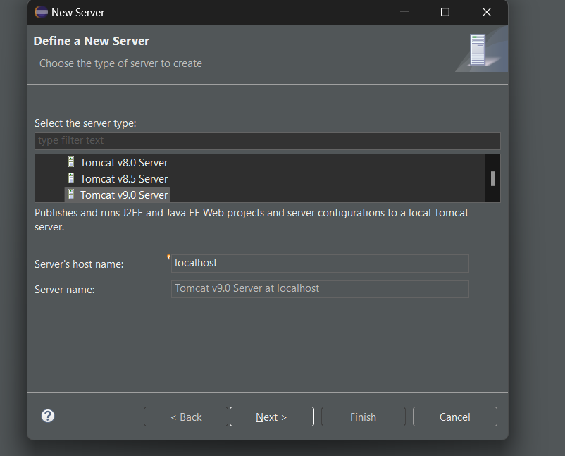

**Browse the Tomcat folder available in your local system as shown**

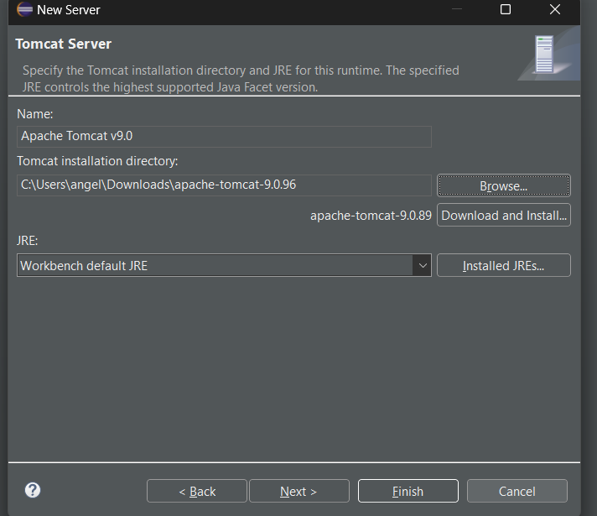

**From now on we can start Tomcat server from Eclipse IDE as shown**

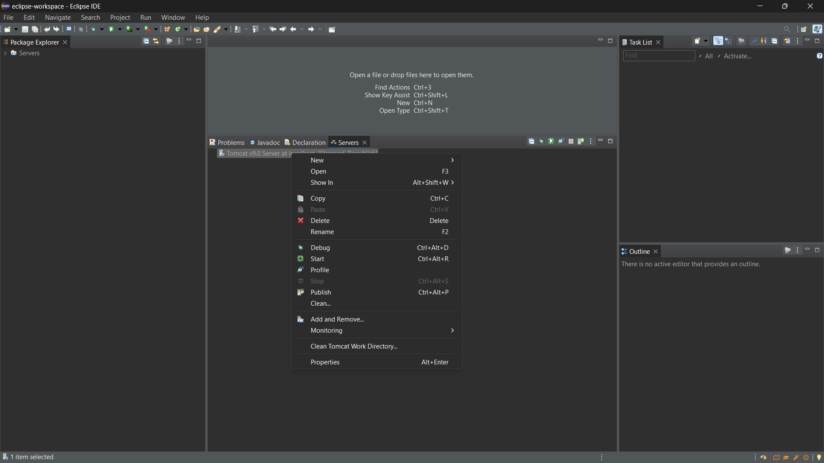

**We can now see that the server is started**

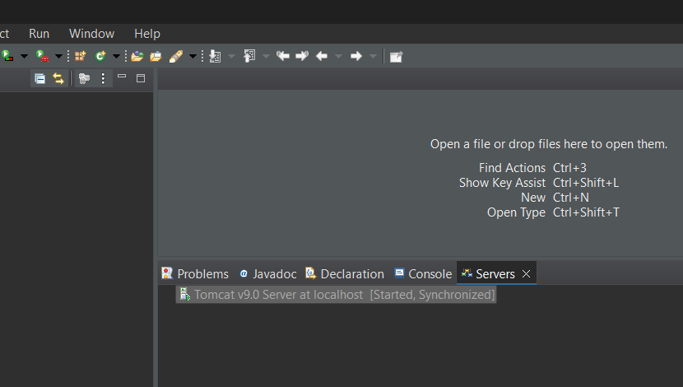

**The next step is to change the port number of the Tomcat as Jenkins uses 8080, as shown**

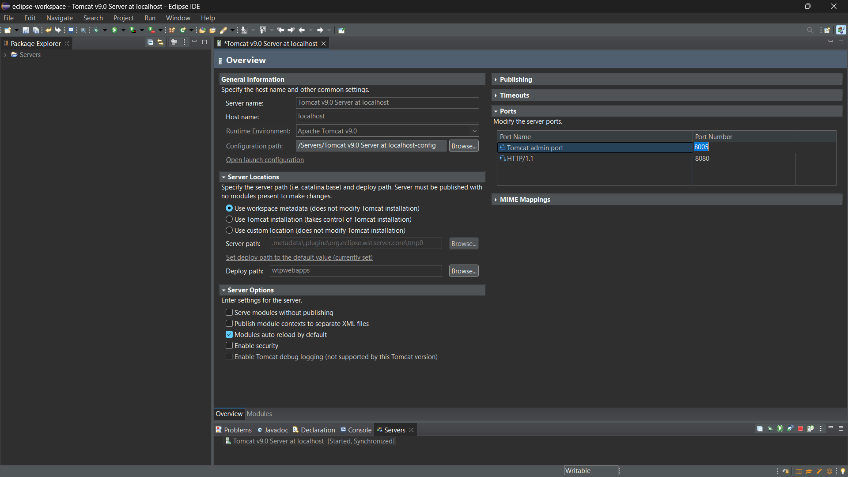

**In server locations make sure second option is selected**

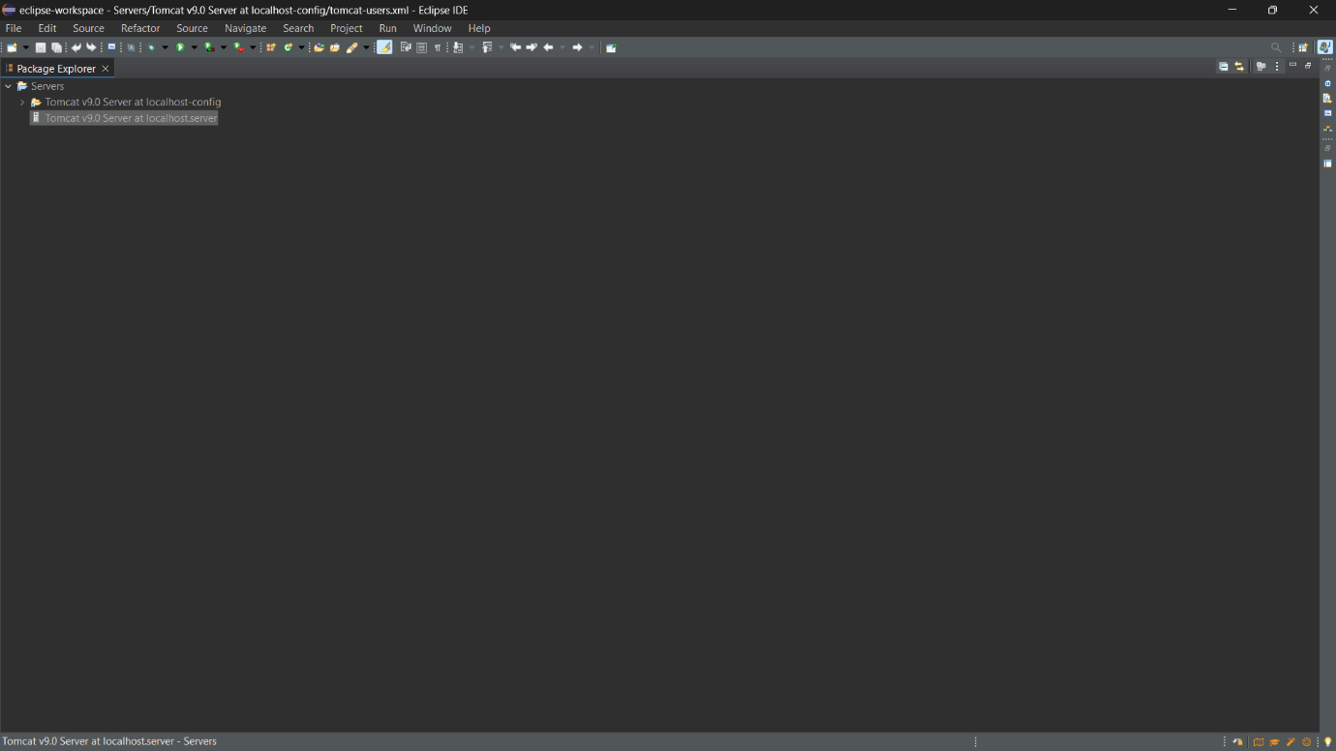

**Copy the following text:**

<role rolename="admin-gui,manager-gui ,manager-script,manager-jmx,manager-status"/>

  <user username=“admin" password="1234"roles="manager-gui, admin-gui ,manager-script"/>

**Open the tomcat-users.xml file as show, and add the highlighted text in the last**

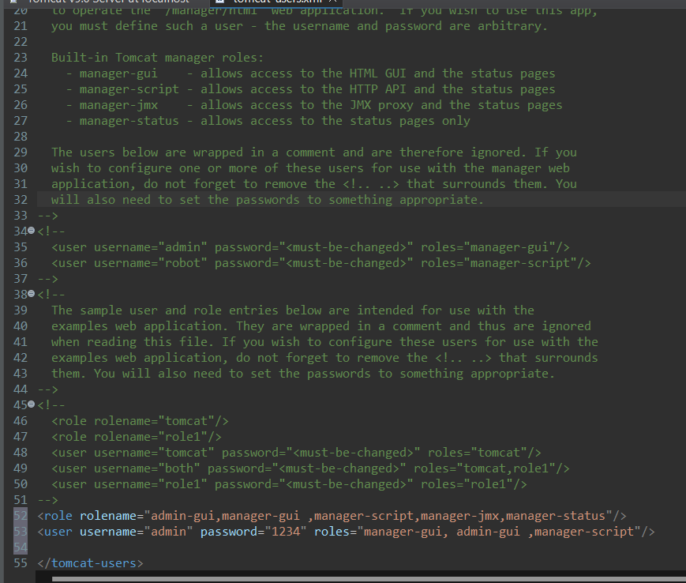

**After the changes, click on save**

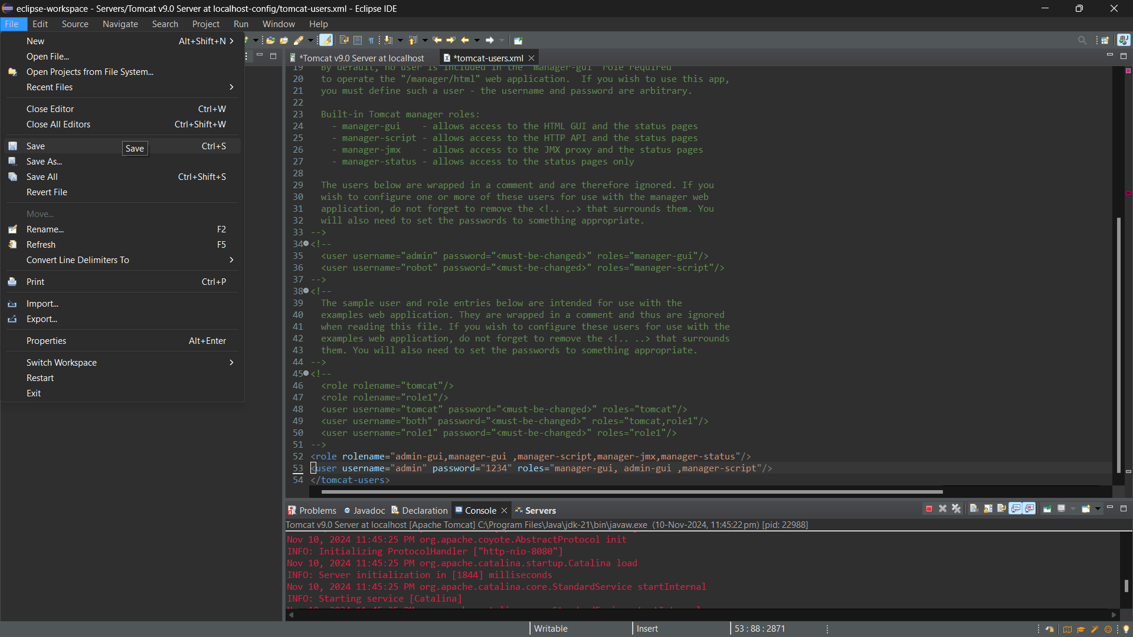

**Now restart the server**

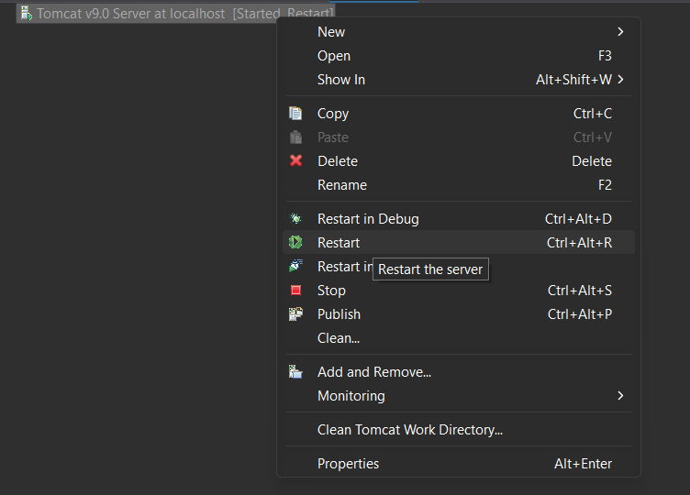

**Click Save**

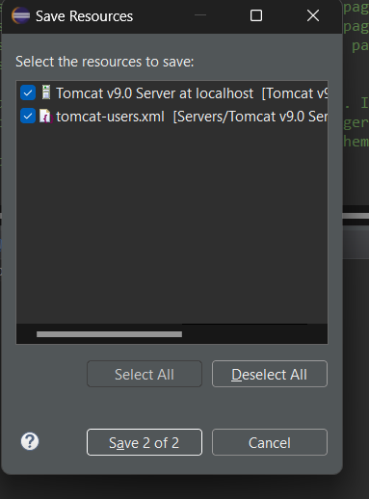

**The server starts**

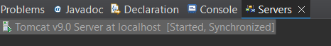

**These are the port numbers**

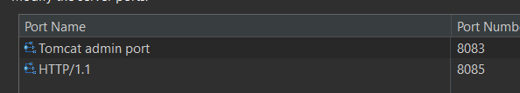

**We can see the Tomcat is successfully running on the new port number**

